

GOVERNMENT OF INDIA

**MINISTRY OF SKILL DEVELOPMENT & ENTREPRENEURSHIP**

DIRECTORATE GENERAL OF TRAINING

**NATIONAL SKILL TRAINING INSTITUTE**

NSTI (W) SALTLAKE KOLKATA

**CERTIFICATE**

This is to certify that following trainees have completed their project titled

**“NSTI Smart Cloud Campus”**

**For IBM Program – IT, Networking and Cloud (Technical Diploma)**

|  |  |
| --- | --- |
| **ROLL NO** | **NAME** |
| ADIT19AU03683 | PUSHPA KUMARI |

|  |  |  |
| --- | --- | --- |
| Mr. Boddu Lingaiah | Mr. K.L Kuli Mr. Ramamurthy | Mr. Sarbojit Neogi |
| IBM Faculty | ADIT Director Head of office/Principal | Section In-charge |

**ACKNOWLEDGEMENT**

We would like to express my sincere gratitude to several individuals and organizations for supporting me throughout my diploma study. First, I wish to express my sincere gratitude to my trainer, Mr. Boddu Lingaiah, for his enthusiasm, patience, insightful comments, helpful information, practical advice and unceasing ideas that have helped me tremendously at all times in my study and writing of this project report. His immense knowledge, profound experience and professional expertise in computer science has enabled me to complete this project successfully.

I also wish to express my sincere thanks to the National Skill Training Institute,Saltlake Kolkata for accepting me into the diploma program. In addition, I am deeply indebted to the Ministry of Skill Development & Entrepreneurship and IBM for granting me the diploma course. This technical and financial support has enabled me to complete my diploma course studies successfully. Also, I am grateful the Mr. Boddu Lingaiah faculty of NSTI Saltlake Kolkata for supporting me for course completion in the specific subject.

I am also grateful to the following NSTI Regional Director Sir Mr. Sarbojit Neogi and Assistant Director Sir Mr. K.L Kuli for their consistent support and assistance.

**ABSTRACT**

The system aims at the maintenance and management of the different Hotels that are available in the different parts of the world. It mainly takes care of the Hotel management at the core area of the database. The system provides the information regarding the different Hotels that are available and their status specific to availability. The guests can visit the site and give the feedback themselves with the required information that is expected by the system. Each registered guest can raise a request for the unit bookings. The Guests are scheduled with the information of the availability of the units for they have requested the time

The total front end was dominated using HTML, CSS and JAVASCRIPT standards applied with the dynamism of NodeJS server pages. The communicating client was designed using AI, Watson Assistant learns from customer conversations, improving its ability to resolve issues the first time while removing the frustration of long wait times, tedious searches and unhelpful chatbot at all proper levels high care was taken to check that the system manages the date consistency with proper business validations. The database connectivity was planned using the MongoDB Database Connectivity, the authorization and authorization was cross checked at all stages. The user level accessibility has been restricted into two zones the administrative and the normal user zone.

**INDEX**

|  |  |  |
| --- | --- | --- |
| **Sr. No.** | **Table of Contents** | **Page No.** |
| 1 | Chapter 1: Introduction | [5](add%20a%20page) |
| 2 | Chapter 2: Services and Tools Required | 6-17 |
| 3 | Chapter 3: Project Architecture | 18 |
| 4 | Chapter 4: Architecture Blocks Detail Working | 19 |
| 5 | Chapter 5: create a webpage using node and add data with mongo DB Atlas | 21-38 |
| 6 | Source Code | 39-74 |
| 7 | Conclusion | 75 |
|  | References | 76 |
| 8 | Screenshot | 77-80 |

**CHAPTER 1**

**INTRODUCTION**

1. **overview**
2. ***Feature***
3. ***Advantages***
4. ***Scope***
5. ***Future Work***

|  |
| --- |
|  |
|  |
|  |
|  |
|  |

**INTRODUCTION**

1. **Overview**

User can easily enter this website and know all about fabulous hotel.

And waston assistant assist the user’s what food available here or not available and anything according to users need and ask the questions waston assistant will give those answers

user can be easily giving his feedback etc...

1. **Feature**

* User easily Althing know about hotel and hotel’s special dishes and food menu
* In food menu user can be known about what is available in breakfast, dinner, main dishes, lunch and deserts dishes and what is the cost of food.
* our waston assistant will assist the users
* user can be contact and also know about the hotel opening and closing timing.

1. **Scope**

This website specially design for saves the time of users and hotel's staff and worker

Half work of staff does this website and chatbot.

1. **Future Work**

**The purpose of the hotel website is to save the users and hotel staff time and as a hotel boss no need to more workers he does his work via few workers. A clear understanding of the hotel website and its functionality will allow for the correct software to be developed for the end-user and will be used for the development of the future stages of the project. On our website, there is an option to book a table online but our future plan is to order food online also because we want to provide full customer satisfaction and we are working on that.**

**CHAPTER 2**

**SERVICES AND TOOLS REQUIRED**

|  |  |  |
| --- | --- | --- |
| **S.I No.** | **Topics** | **Page No** |
| 1 | Services Used | 7-14 |
| a | Waston Assistant | 7 |
| b | What is actions in waston | 7 |
| c | Create a waston assistant using actions method | 7-13 |
| d | how to add html page a waston | 14 |
| 2 | Used technology | 16-17 |

**SERVICES AND TOOLS REQUIRED**

**2.1. Services Used**

1. **IBM Waston Assistant**

Watson Assistant is chatbot that provides customers with fast, consistent and accurate answers across any application, device or channel. Using AI, Watson Assistant learns from customer conversations, improving its ability to resolve issues the first time while removing the frustration of long wait times, tedious searches and unhelpful chatbots.

1. **What is Actions in IBM Watson Assistant?**

A new feature has been added to IBM Watson Assistant called Actions. This new feature allows users to develop dialogs in a rapid fashion.

1. **Build a waston chatbot using actions**

**Step 1**

* **Click on this link**

<https://cloud.ibm.com/login?redirect=%2Faccount%2Fcloud-foundry>

* Login to IBM cloud
* Give your IBM cloud credential

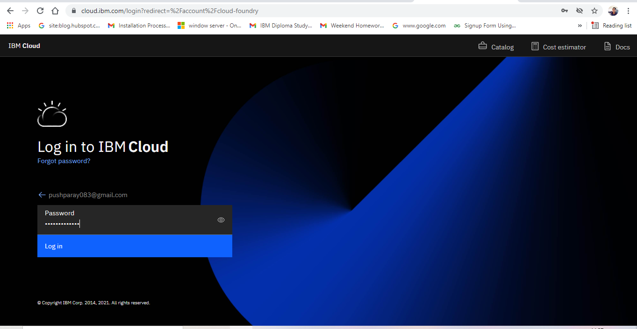

* You can see open your dashboard
* Search on search box chatbot
* Select Waston Assistant

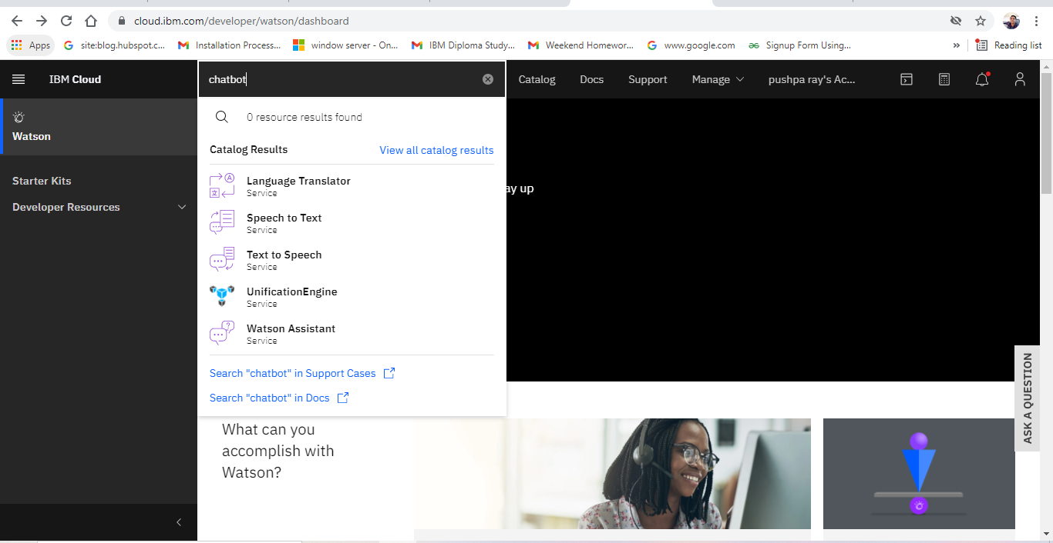

* We go this page.
* Prove the certain name of application.
* Click on create.

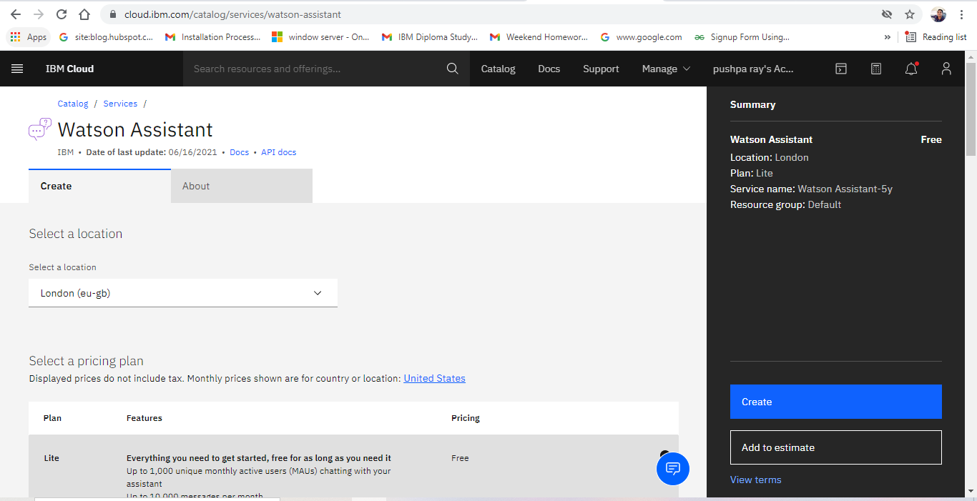

* You can see created waston assistant
* Click on launch waston assistant

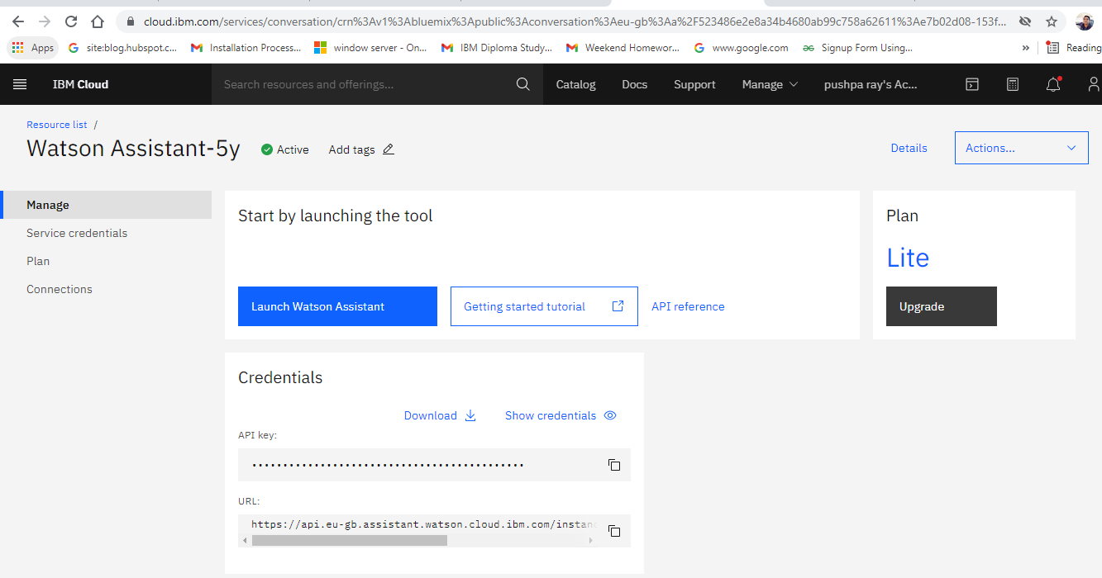

**Step 2**

Click on integration

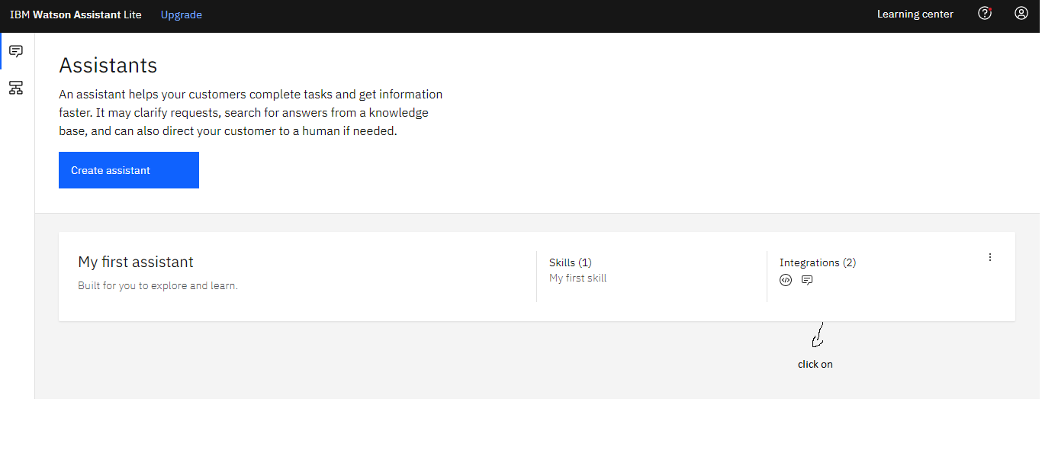

After that click on

That indicated to image

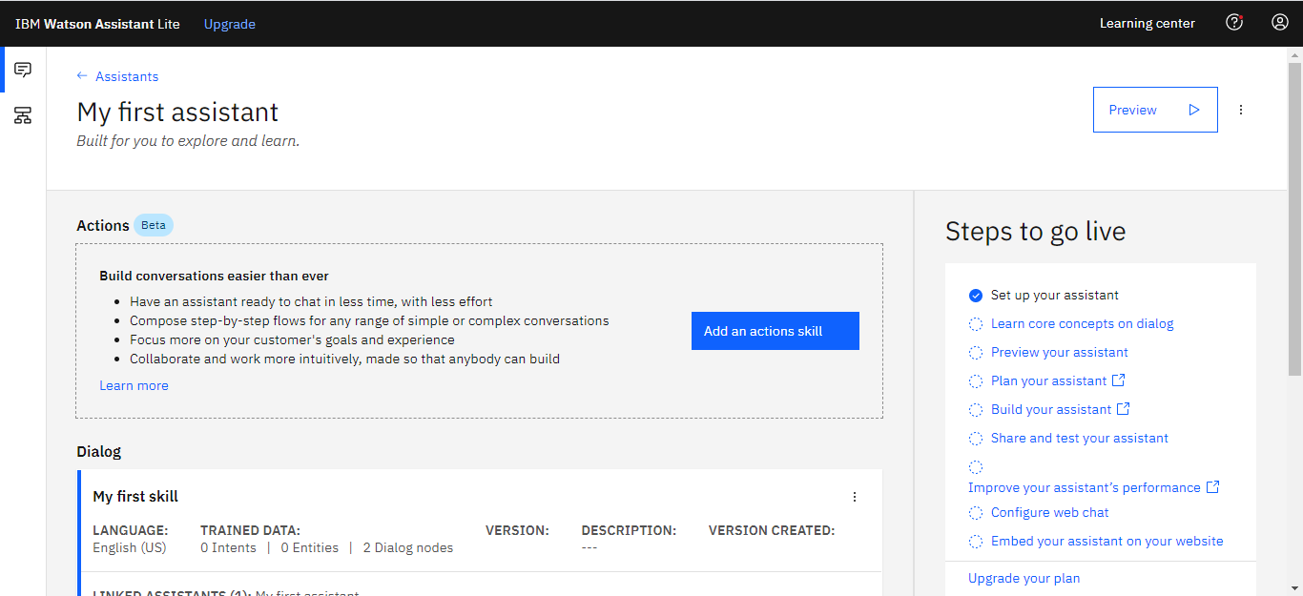

**Click on create a new action**

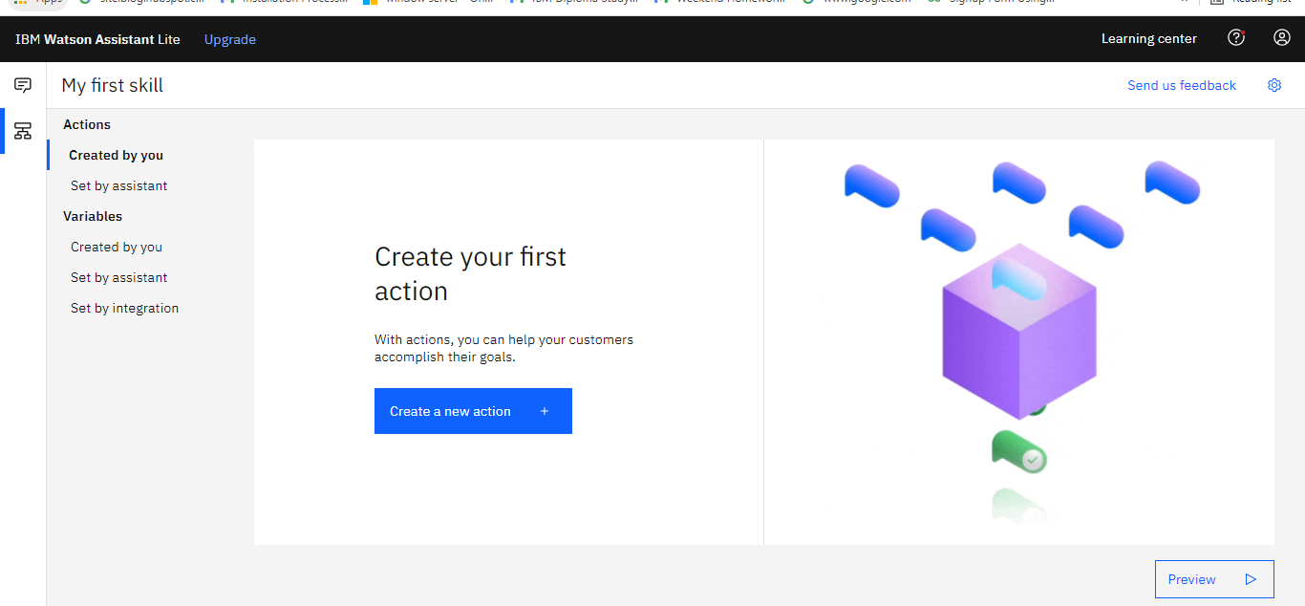

We get this page

* Give customer questions
* click on new step
* Provide the assistant response
* Following this step create a chatbot waston assistant using actions

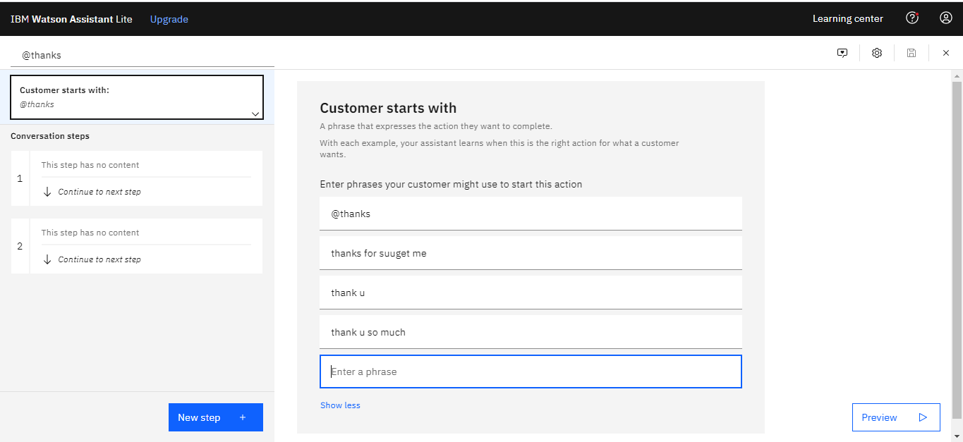

There are actions created by me

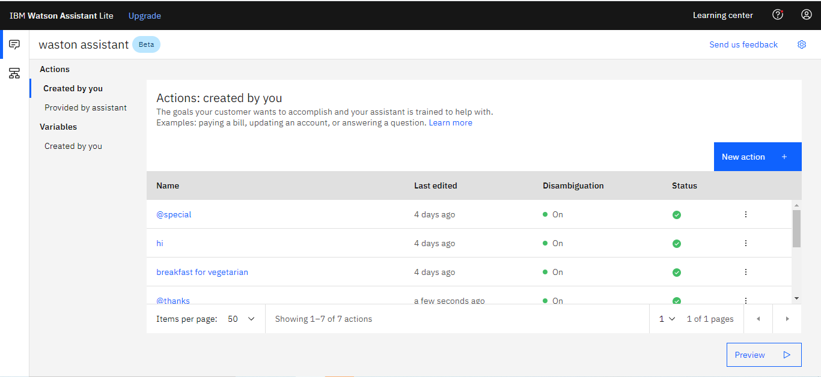

**Step 3**

1. **How to check chatbot properly run or not**

Click on preview



Write the user question

I have provided hi in that chatbot

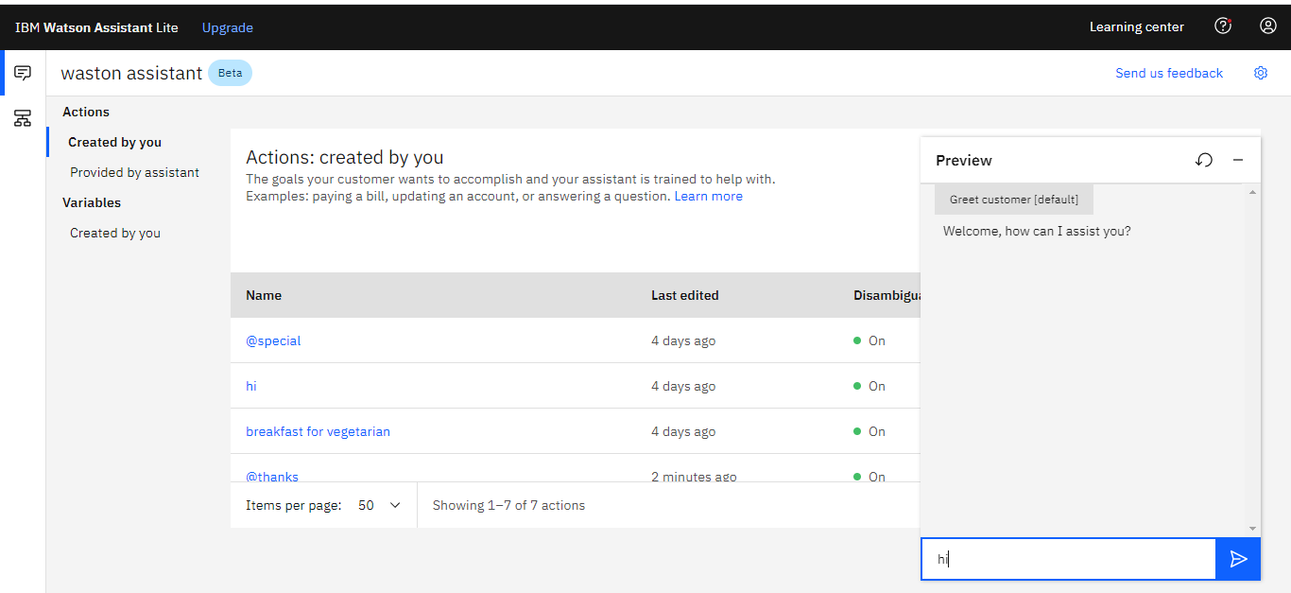

You can see in image chatbot give the user response

That means our chatbot successfully created

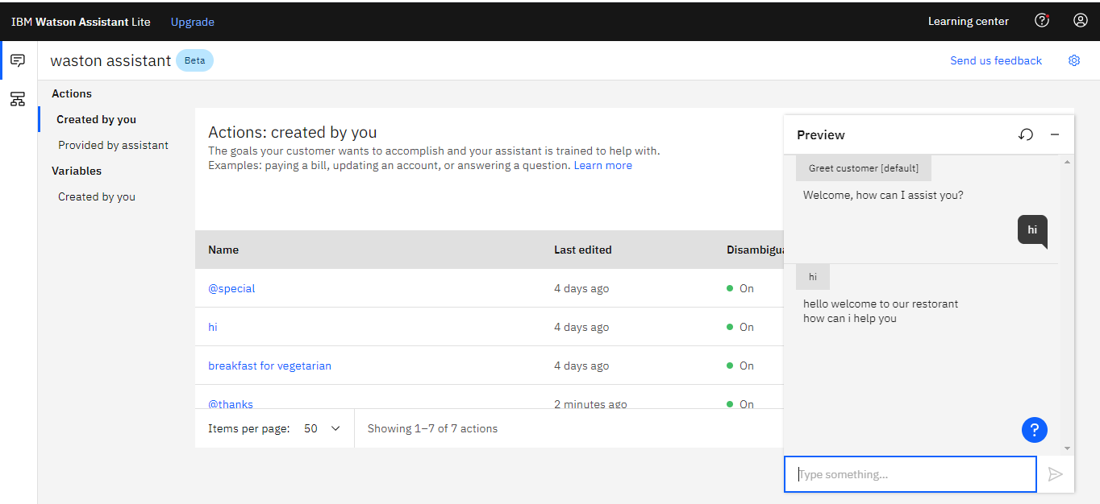

**Step 4**

**How to add waston assistant in a static webpage**

Go to web chat

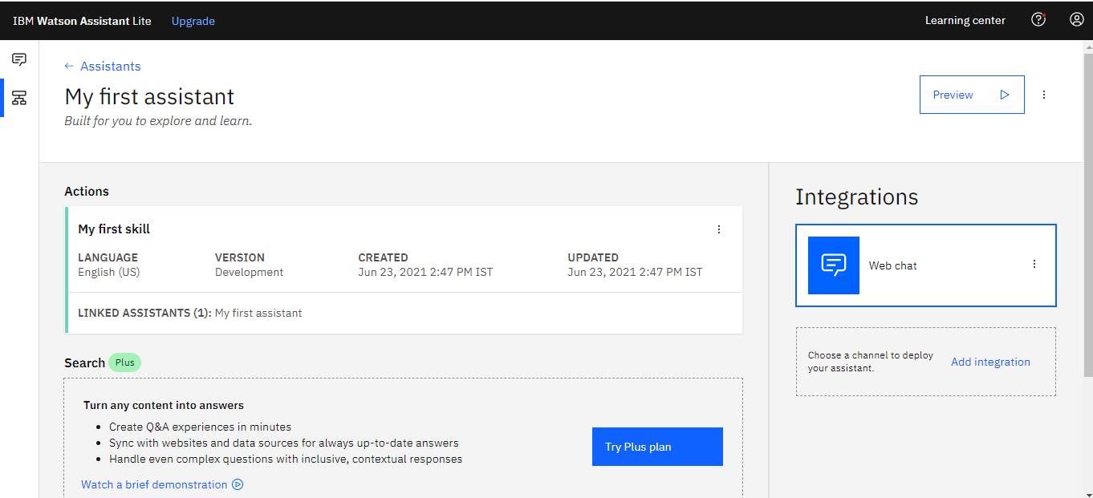

* Click on embedded
* Copy the link
* Paste it your html page

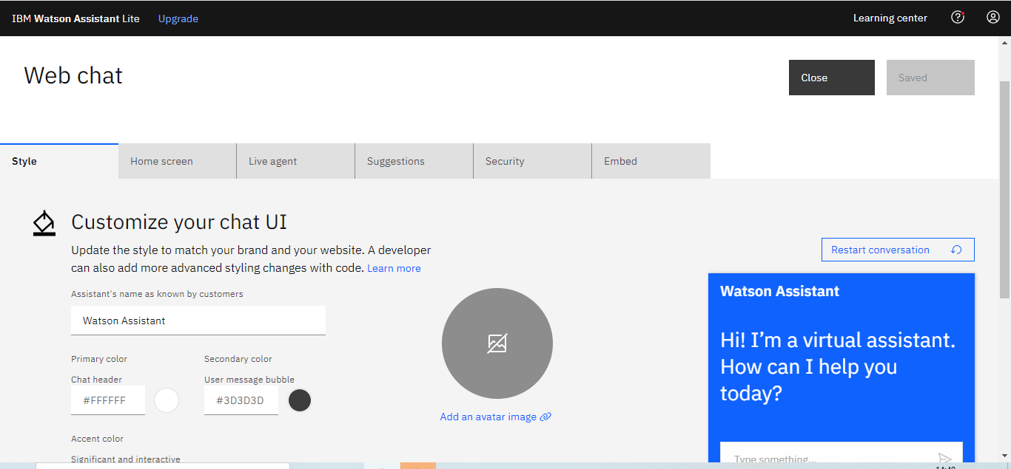

**2.2 Tools and Software used**

**Used Software**

* Node.js
* MongoDB Compass
* VS Code Editor

**Used Hardware**

Processor: - Intel Core i3 & Higher Version

Operating System: - Windows 10

Memory: - :- 4GB RAM

Hard Disk: - :- 1TB Hard Disk

**Used Technology**

* HTML
* CSS
* JAVASCRIPT
* EXPRESS.JS
* EJS

**Run time Environment**

**Node.js**

**Database**

**Mongo dB compass**

1. **HTML**

The Hypertext Markup Language, or HTML is the standard markup language for documents designed to be displayed in a web browser. It can be assisted by technologies such as Cascading Style Sheets (CSS) and scripting languages such as JavaScript.

Web browsers receive HTML documents from a web server or from local storage and render the documents into multimedia web pages. HTML describes the structure of a web page semantically and originally included cues for the appearance of the document.

1. **CSS**

Cascading Style Sheets (CSS) is a style sheet language used for describing the presentation of a document written in a markup language such as HTML.

CSS is a cornerstone technology of the World Wide Web, alongside HTML and JavaScript.

CSS is designed to enable the separation of presentation and content, including layout, colours, and fonts. This separation can improve content accessibility, provide more flexibility and control in the specification of presentation characteristics, enable multiple web pages to share formatting by specifying the relevant CSS in a separate .CSS file which reduces complexity and repetition in the structural content as well as enabling the .CSS file to be cached to improve the page load speed between the pages that share the file and its formatting.

1. **JavaScript**

JavaScript (JS) is a lightweight, interpreted, or just-in-time compiled programming language with first-class functions. While it is most well-known as the scripting language for Web pages, many non-browser environments also use it, such as Node.js, Apache CouchDB and Adobe Acrobat. JavaScript is a prototype-based, multi-paradigm, single-threaded, dynamic language, supporting object-oriented, imperative, and declarative (e.g., functional programming) styles. Read more about JavaScript.

This section is dedicated to the JavaScript language itself, and not the parts that are specific to Web pages or other host environments. For information about API specifics to Web pages, please see Web APIs and DOM.

1. **Express.js**

Express.js, or simply Express, is a back-end web application framework for Node.js, released as free and open-source software under the MIT License. It is designed for building web applications and APIs.[3] It has been called the de facto standard server framework for Node.js.

1. **EJS**

Ejs stands for [Embedded JavaScript templates.](https://ejs.co/) It can be used as an alternative template engine.

In this article, you will learn how to apply EJS to an Express application, include repeatable parts of your site, and pass data to the views.

1. **NodeJS**

**As an asynchronous event-driven JavaScript runtime, Node.js is designed to build scalable network applications. In the following "hello world" example, many connections can be handled concurrently. Upon each connection, the call back is fired, but if there is no work to be done, Node.js will sleep.**

1. **Mongo dB Atlas**

MongoDB Atlas is a fully-managed cloud database developed by the same people that build MongoDB. Atlas handles all the complexity of deploying, managing, and healing your deployments on the cloud service provider of your choice (AWS, Azure, and GCP).

**CHAPTER 3**

**PROJECT ARCHITECTURE**

**3.1 Architecture**

**USER FRONTEND BACKEND**

|  |  |  |
| --- | --- | --- |
| **User Internet** | **Web designHTML 5** | Node.js JavaScript npm Computer Icons Web application, text, logo png |  PNGEgg**NODEJS 14.0**  **Database**  MongoDB as a Glassfish Security Realm | Oracle The Aquarium Blog |

**CHAPTER 4**

**ARCHITECTURE BLOCKS DETAIL WORKING**

**4.1 Blocks**

**ER Diagram**

**HOME**



**ABOUT**

**SPECIAL DISHES**

**FOOD MENU**

**ABOUT CHEF**

**CONTACT US**

**CHAPTER 5**

**Develop an application using Node.js and add data with mongo DB database**

|  |  |  |
| --- | --- | --- |
| ***S.I No*** | ***Topics*** | ***Page No*** |
| *1.a* | Creating files | *22* |
| *b* | Install *dependencies* modules *for NodeJS* server | *23* |
| *2* | *Connect our data with mongo dB Atlas* | *24-38* |
| a | Create an account in mongo dB | 25-27 |
| *b* | *Account setup* | *28* |
| *c* | *Create cluster* | *29-30* |
| *d* | *Add data with mongo dB database* | *30-38* |

*.*

1. ***Creating files***

Create folder

I have created a project folder

Inside project folder I have created those 3 files & folder

1. index.html
2. Public
3. App.js

You can see in image those folders

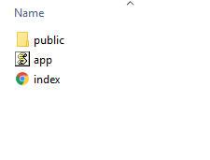

Public folder

You can see in image

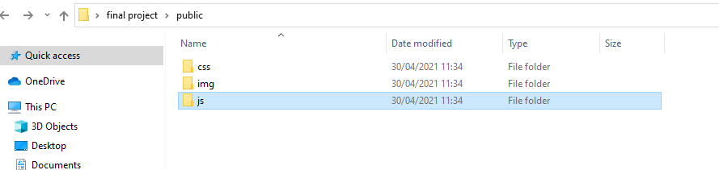

1. **Install dependencies modules**
2. Install express module using command npm install express – save
3. Install body-parser using command npm install body-parser

These are modules required to do this activity

After that start the application on node.js server

Write down on terminal node aap.js

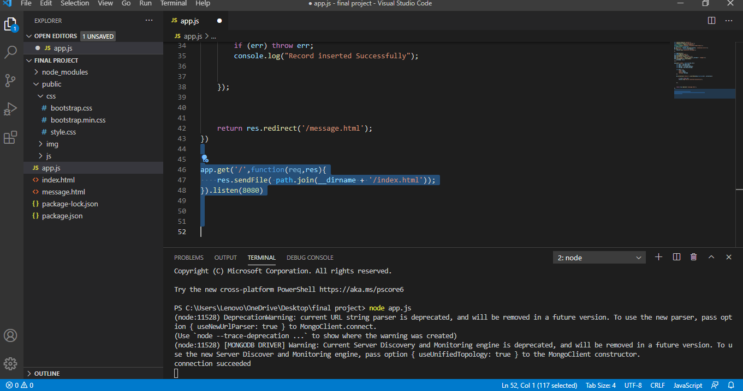

1. **Run application NodeJS server**

go to browser and type localhost:8080

deploy the static webpage locally see the picture

This is the main page

You can my web page running locally on 8080 port No

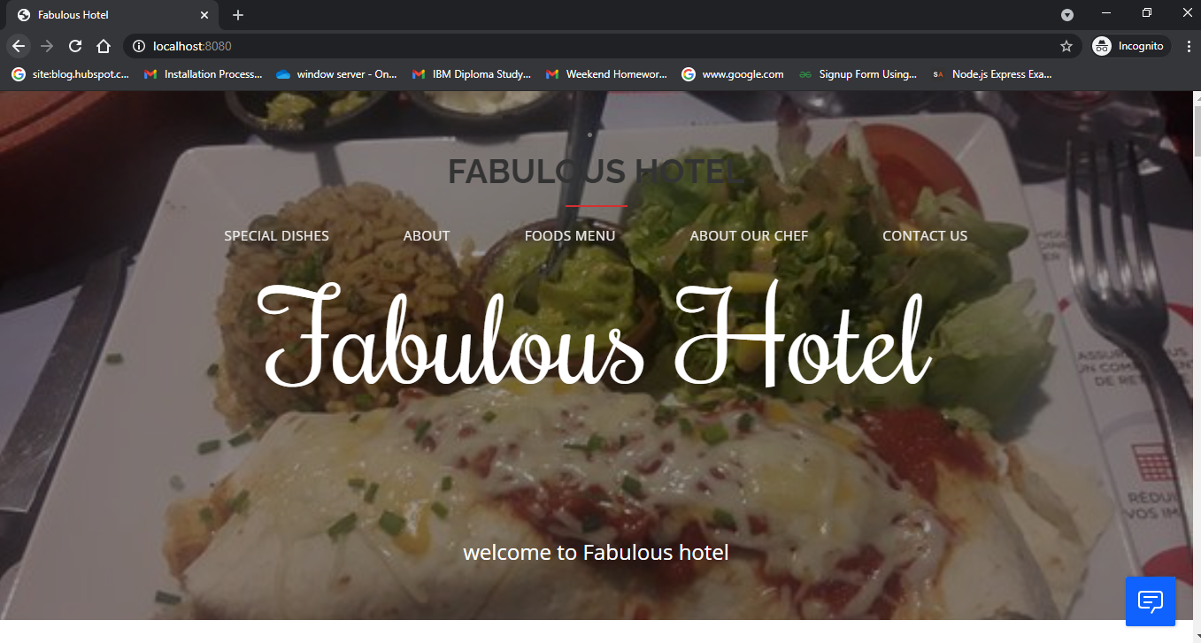

**connect our data with mongo DB Atlas**

1. **install dependencies modules**

* Install mongoose using command npm install mongoose
* Install ejs using command npm install ejs

For store user data we have to need created a views folder

* Create an ejs file
* I have created a message.ejs file
* Such as You see in image

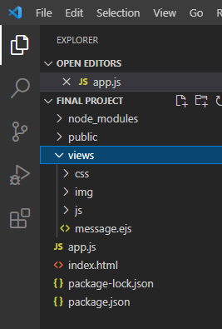

**2. create an account in mongo dB Atlas**

**step 1**

**go this link**

<https://www.mongodb.com/>

**click on sign in button**

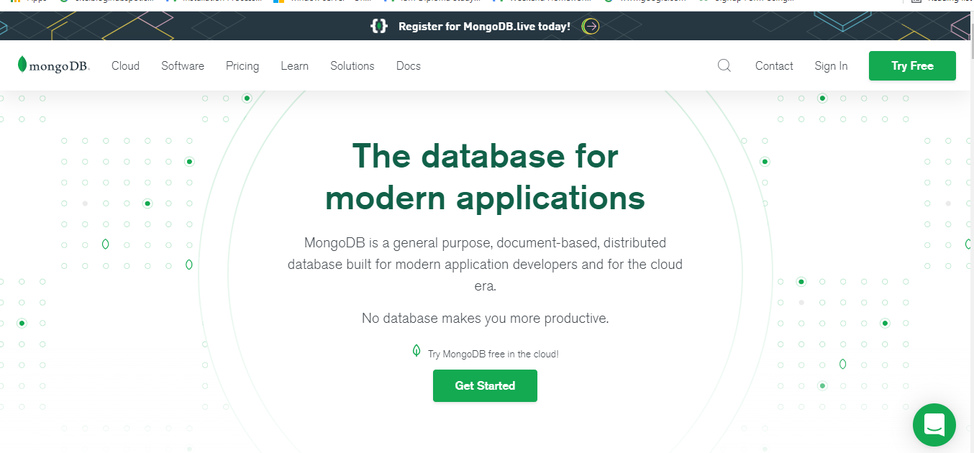

**Click on sign up**

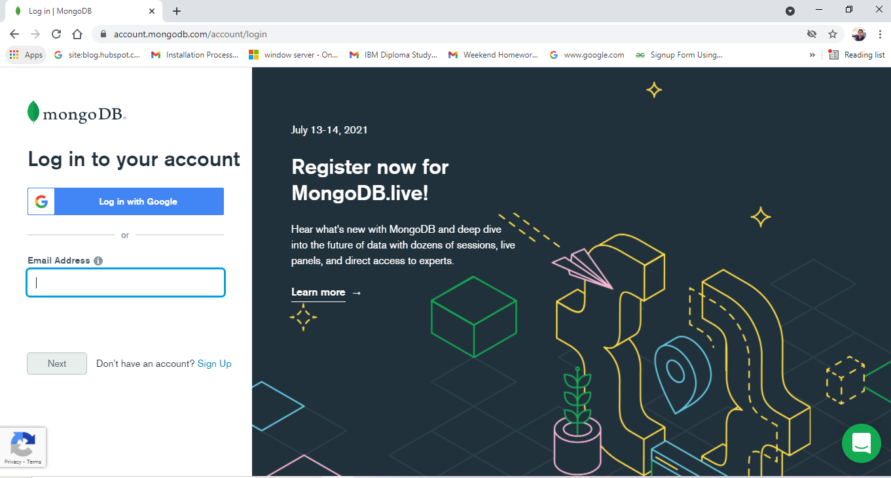

**Click on sign up with google**

**You select your email id**

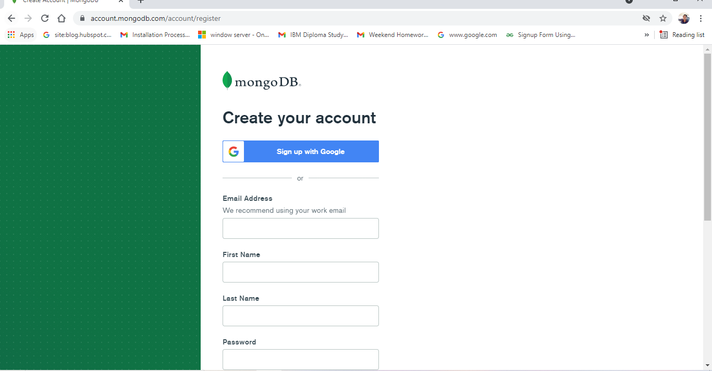

**Accept term & condition**

**Check the button click on submit**

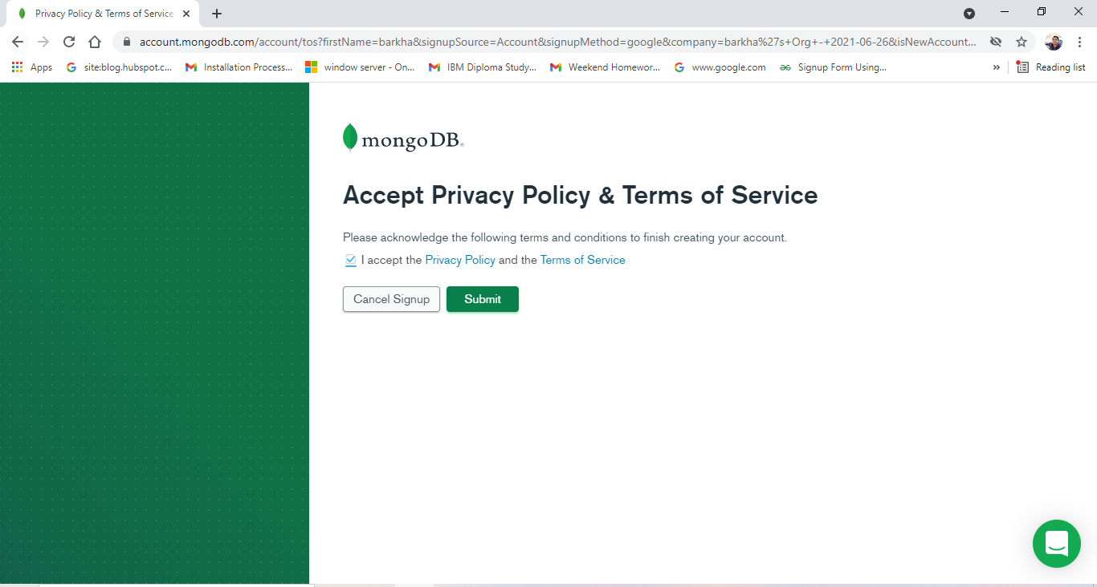

**You can create my account**

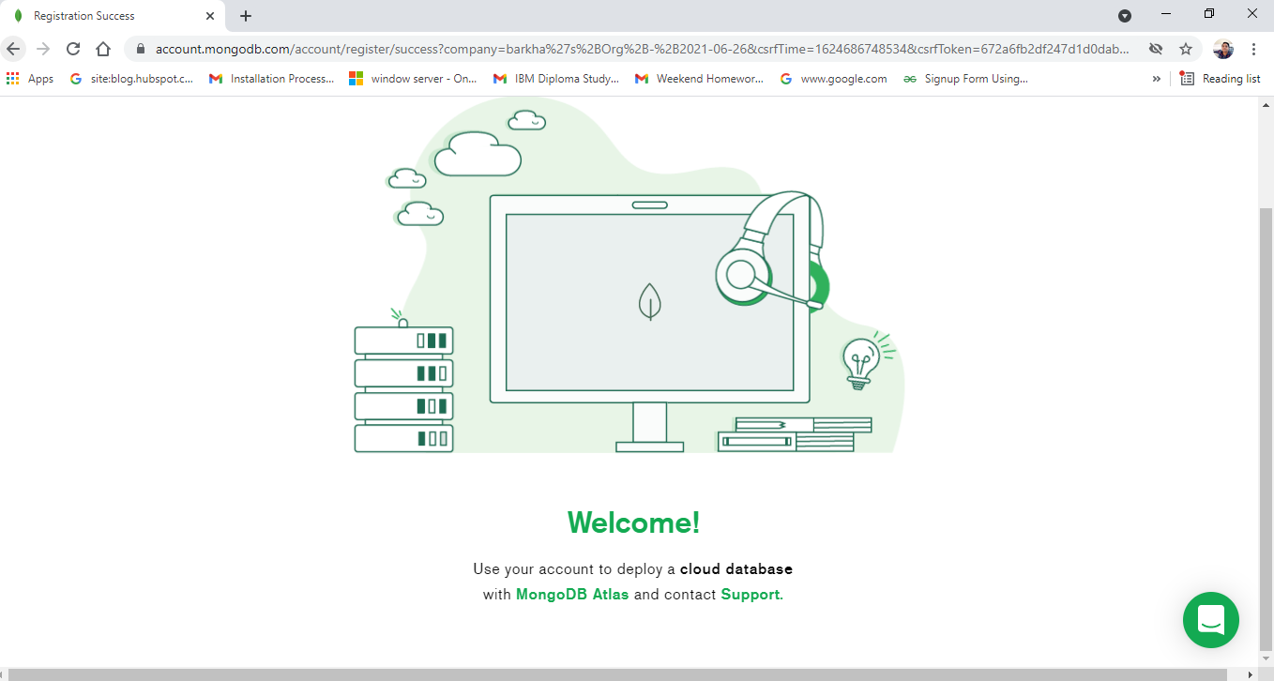

1. **Account Setup**

**Setup your account or go ahead individual**

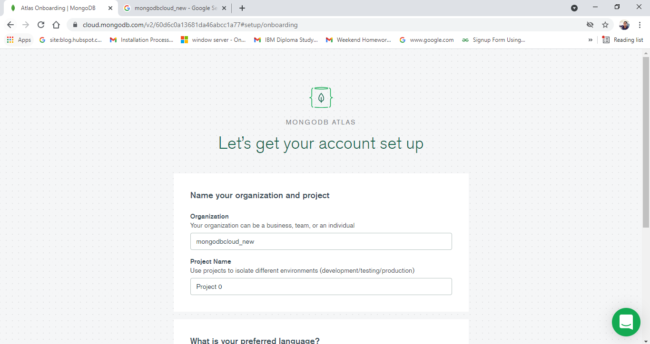

**Select java language**

**Click on continue**

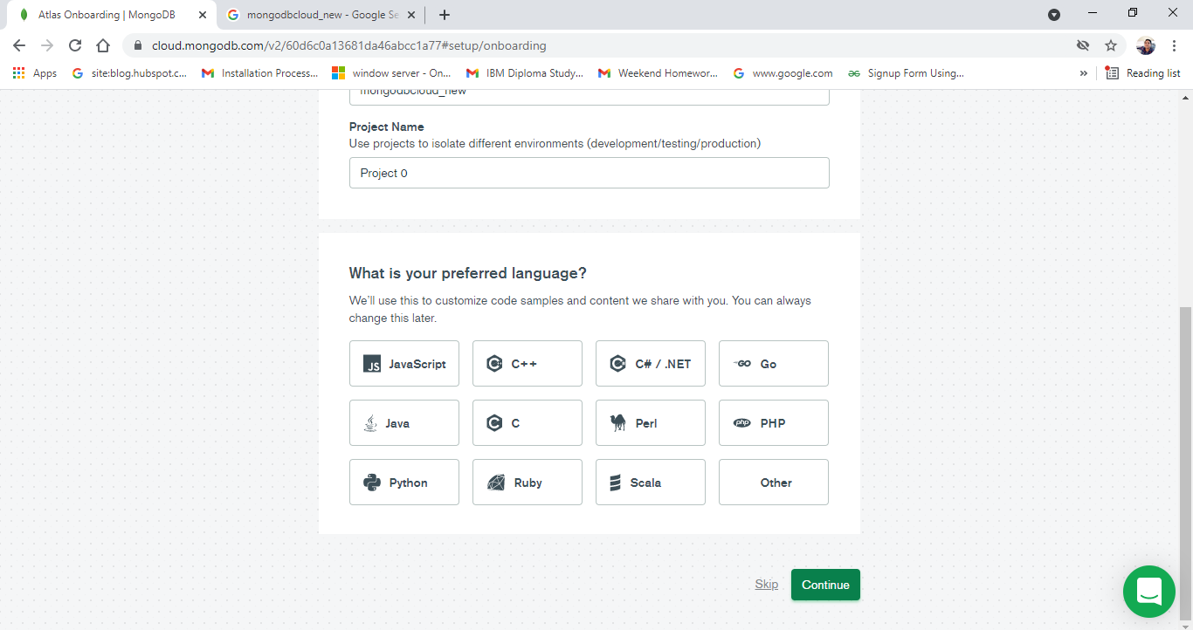

1. **Create a cluster**

**Select free plan**

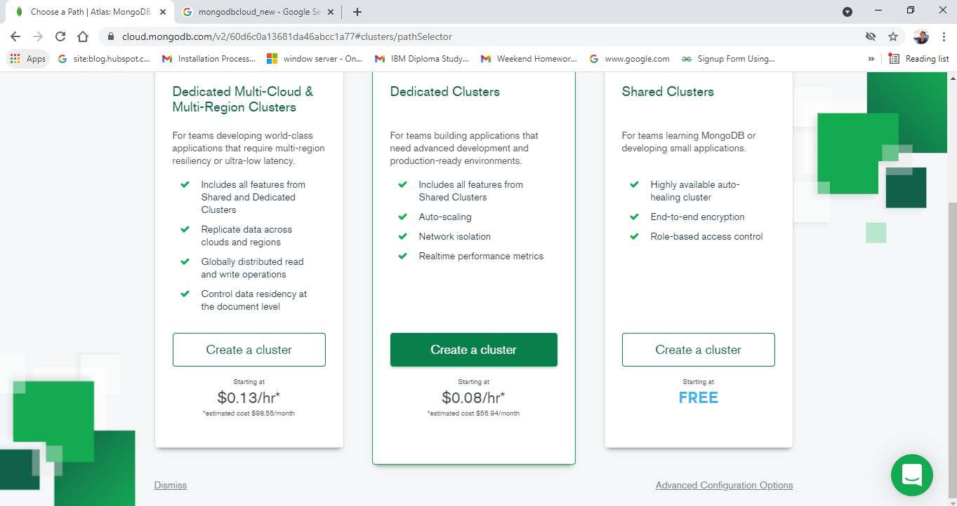

**Click on create cluster**

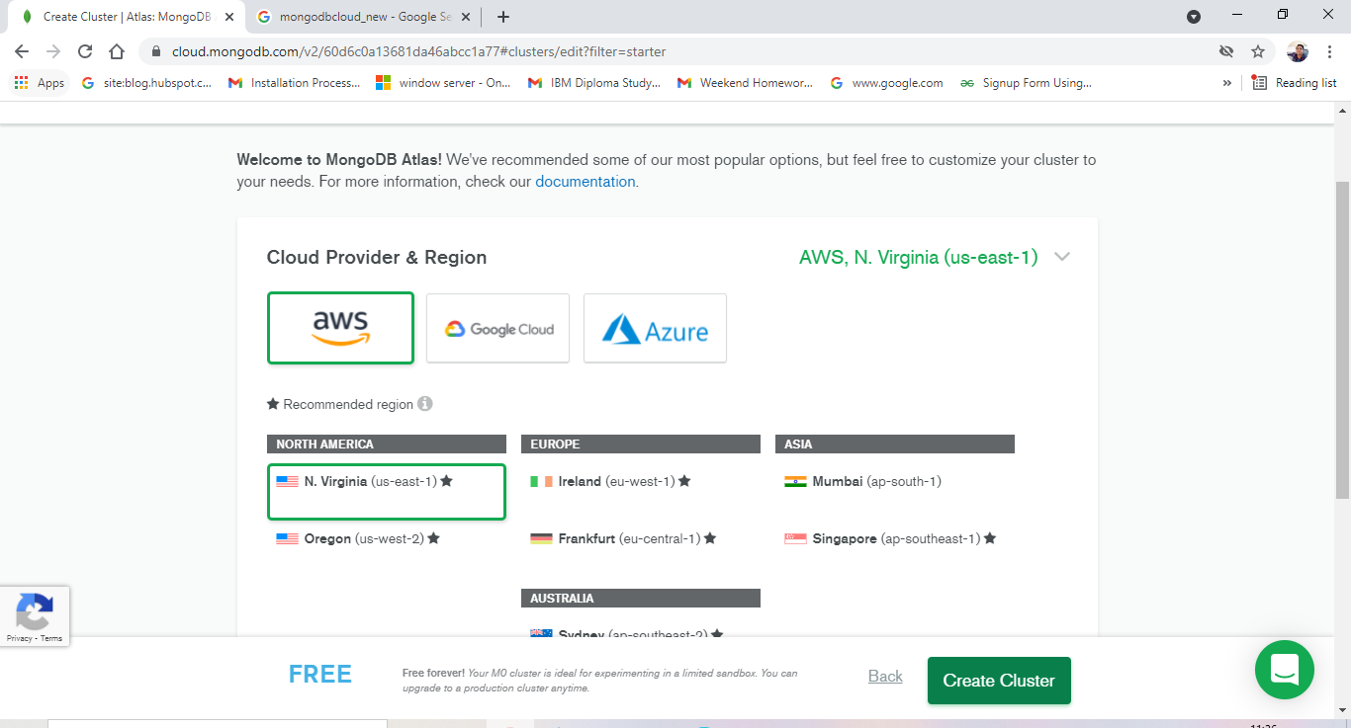

**You can see open this page**

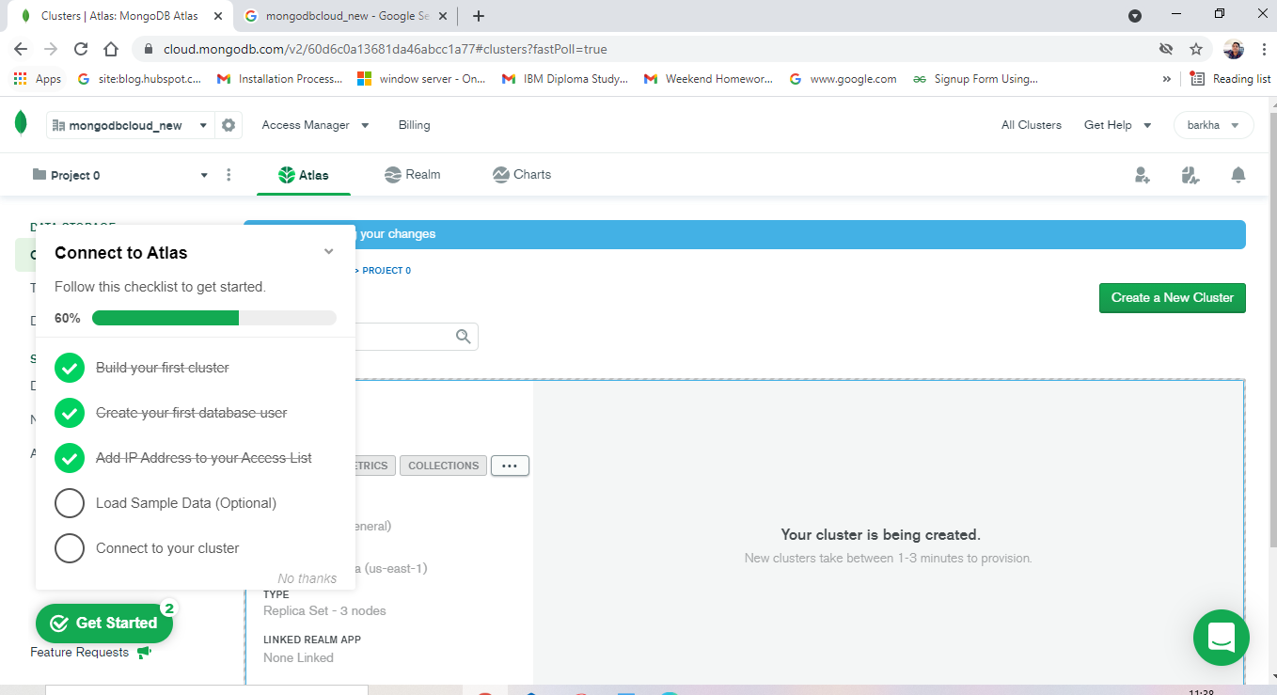

**D.Add Data with Mongo dB**

**Click on data access**

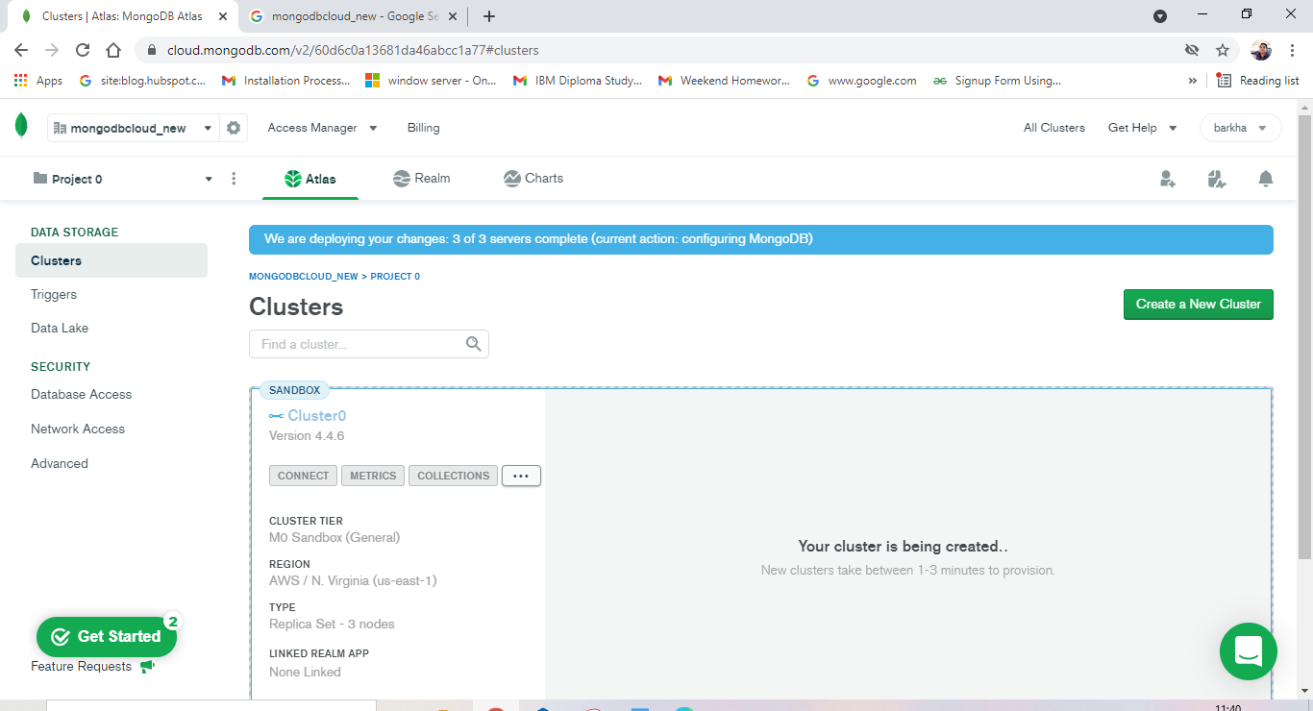

**Click on add new user**

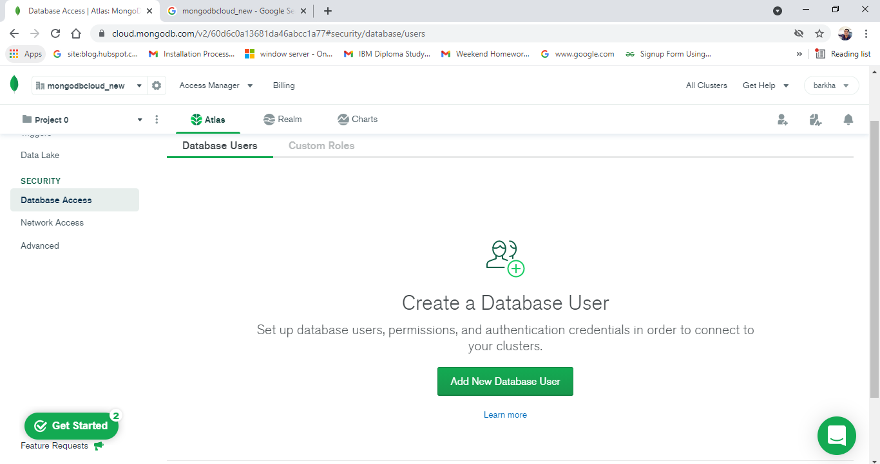

**Give the user’s name & password**

**Click on add user**

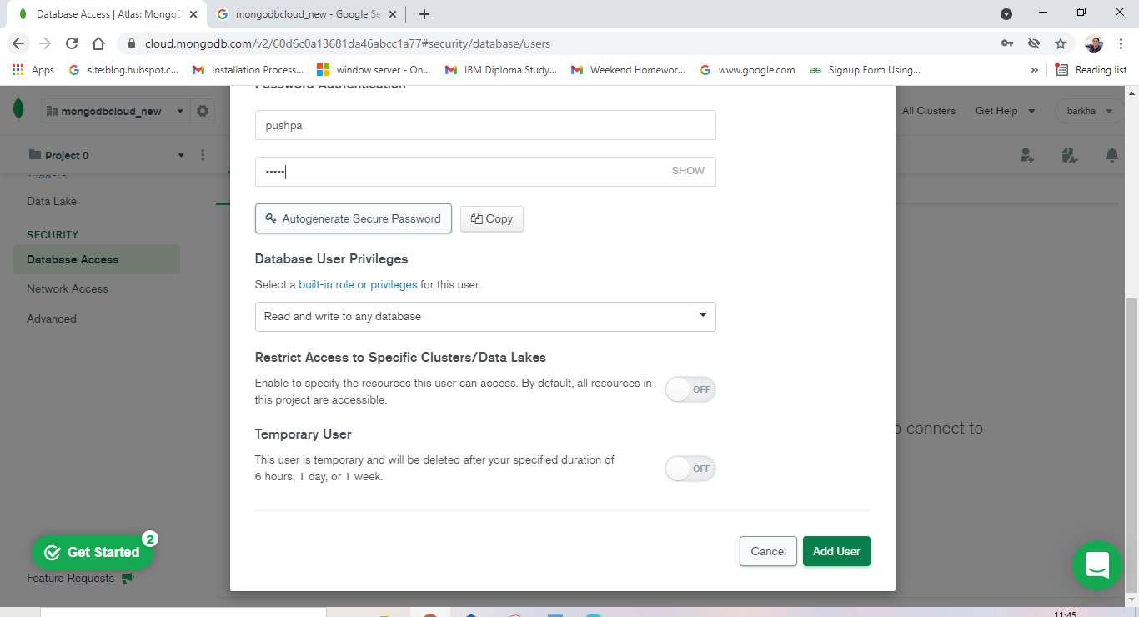

**You able to see added your user**

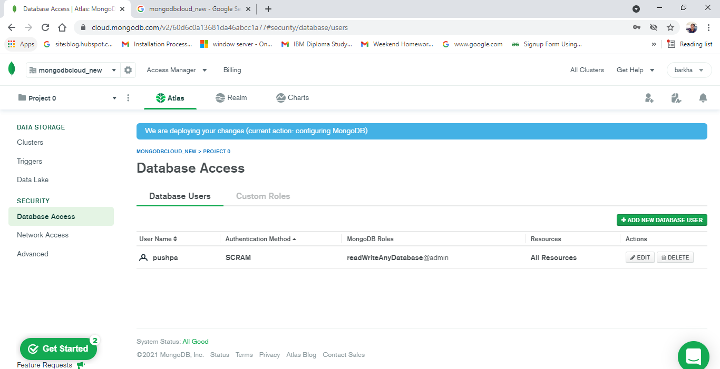

**Click on network access**

**Add Ip address**

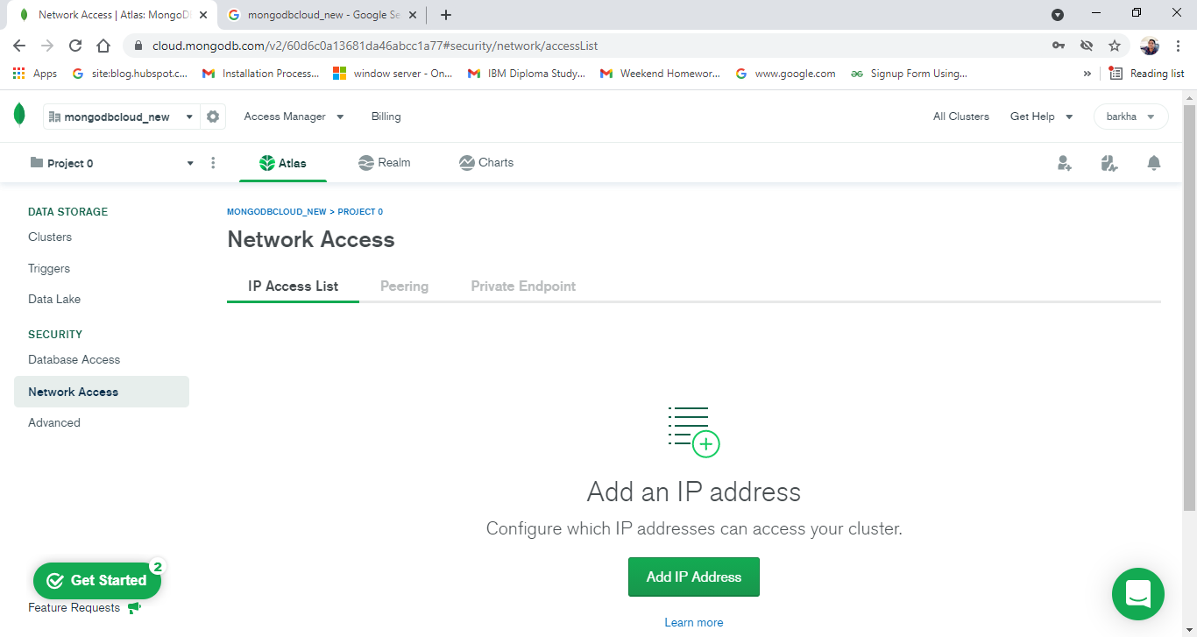

**Select allow anywhere**

**Click on confirm**

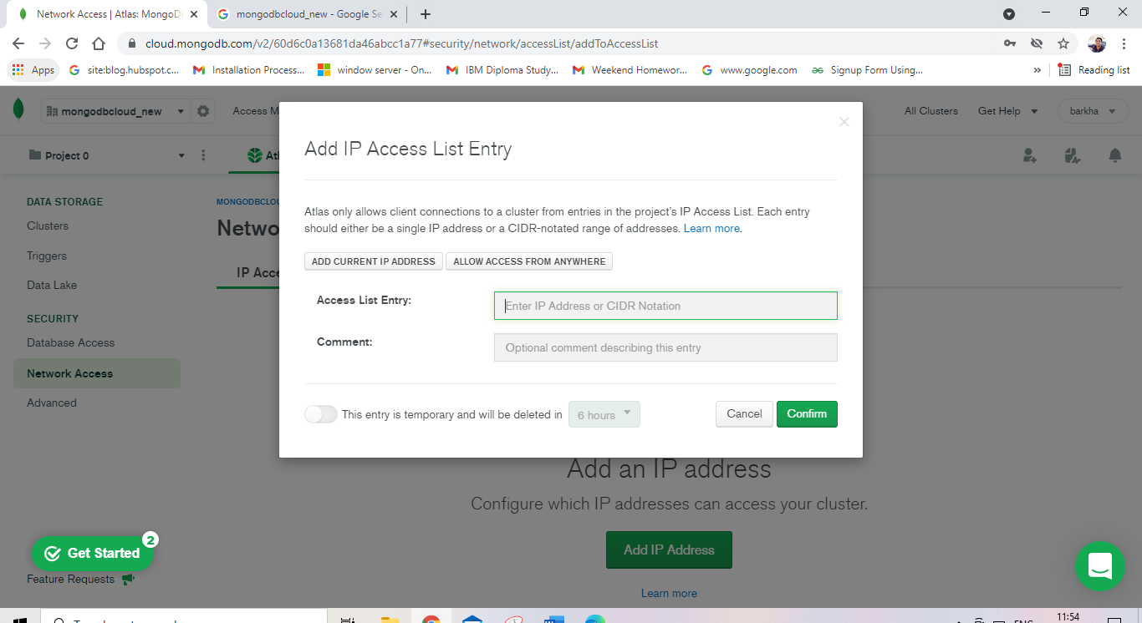

**You can see active in status IP**

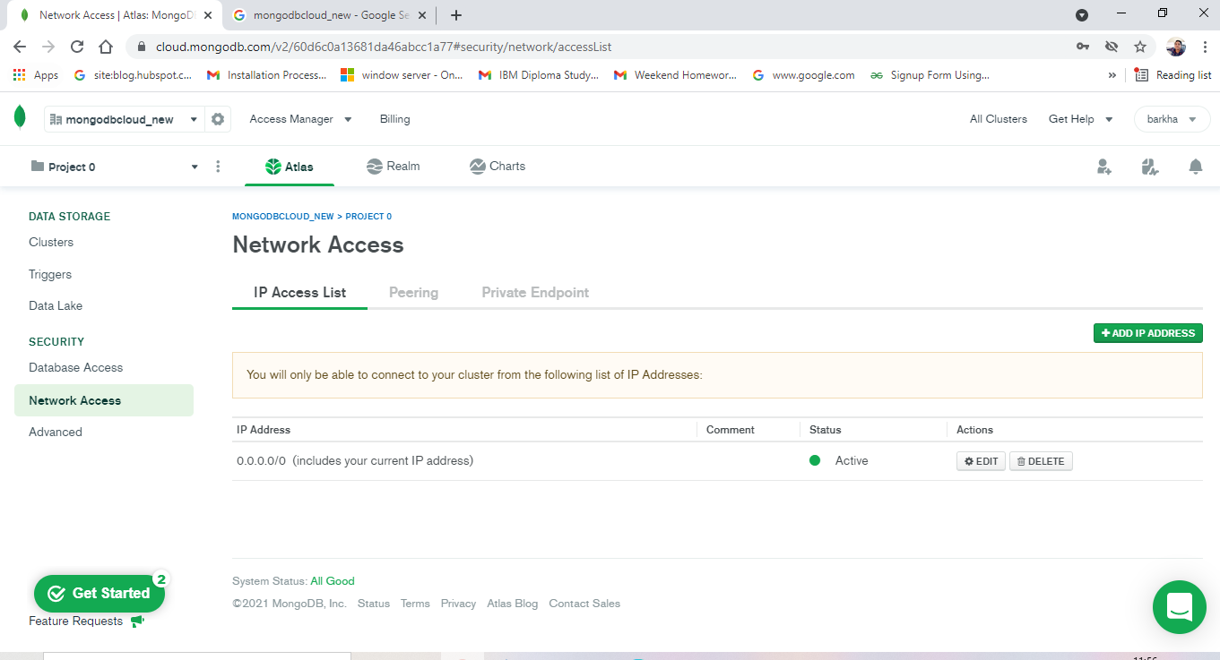

**Go to cluster**

**Click on connect**

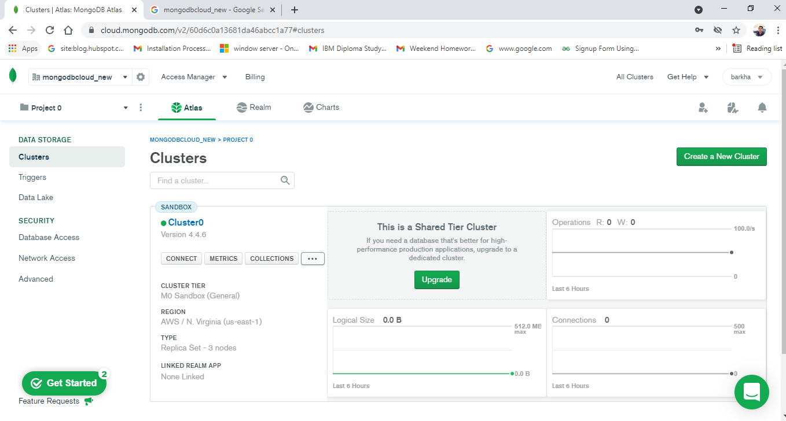

**Select connect your application**

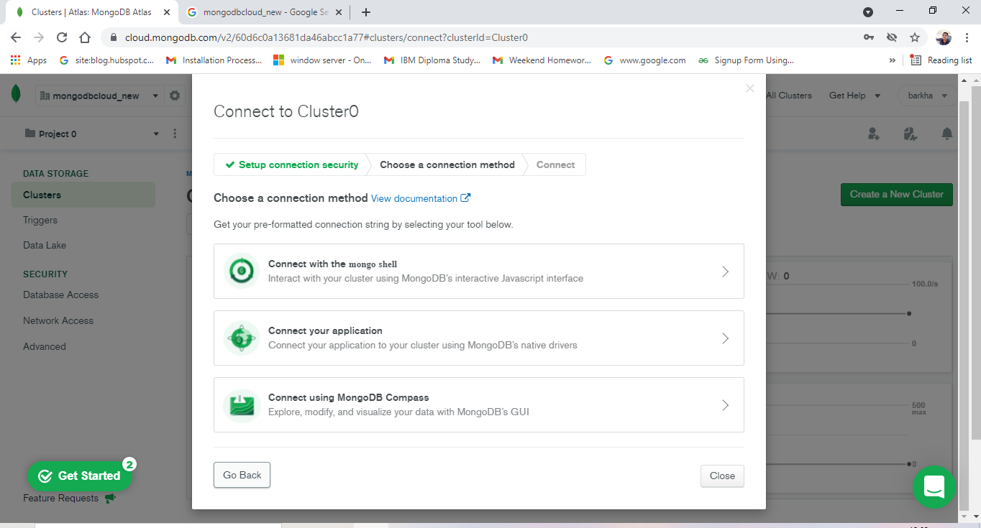

**Copy the link**

**Paste it your app.js file**

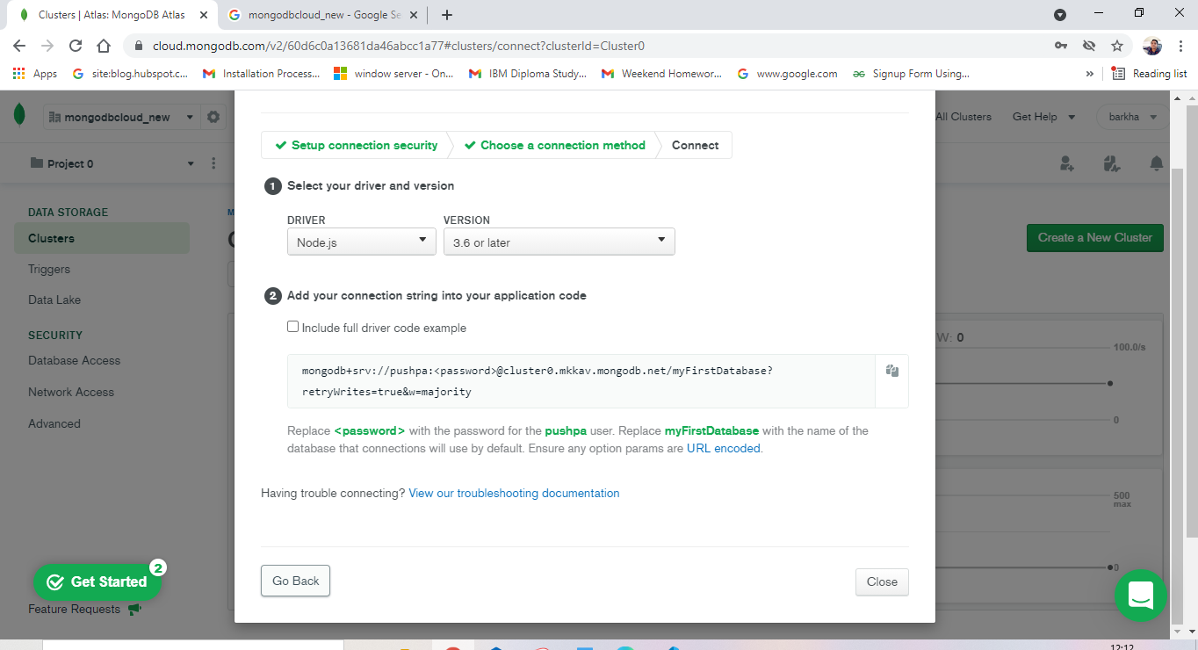

**You can see it image**

**Save it**

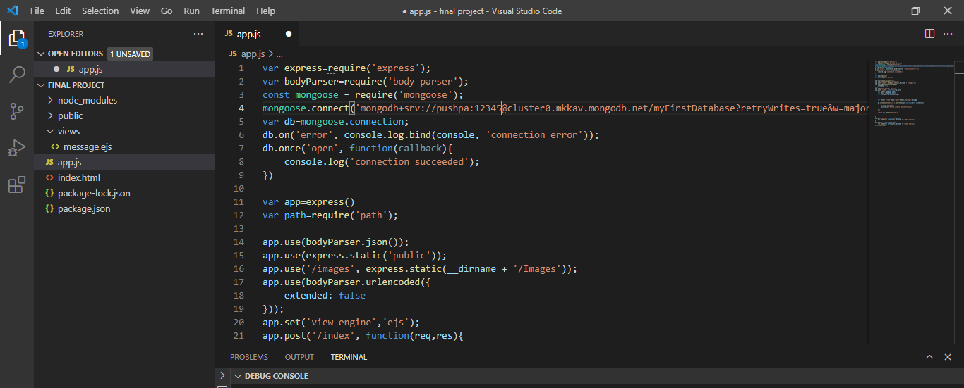

Run the command node app.js in terminal

Press enter

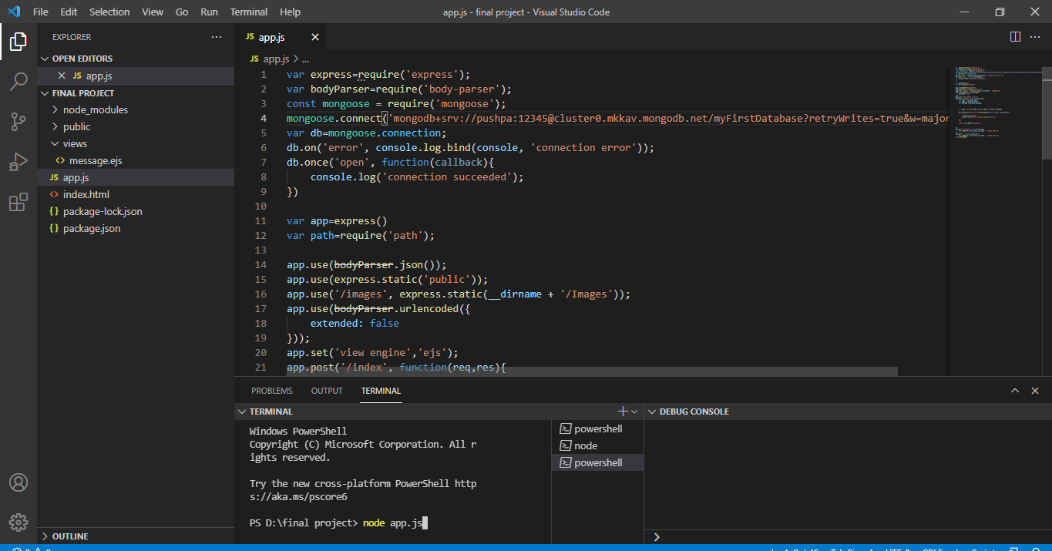

**My webpage run on 8080 port no**

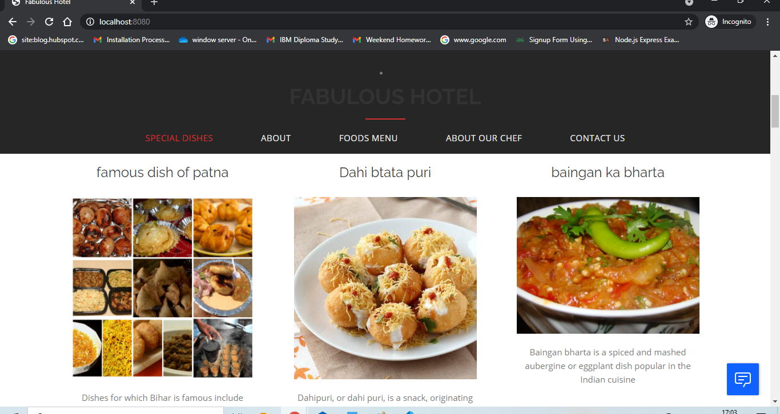

**User sending his feedback**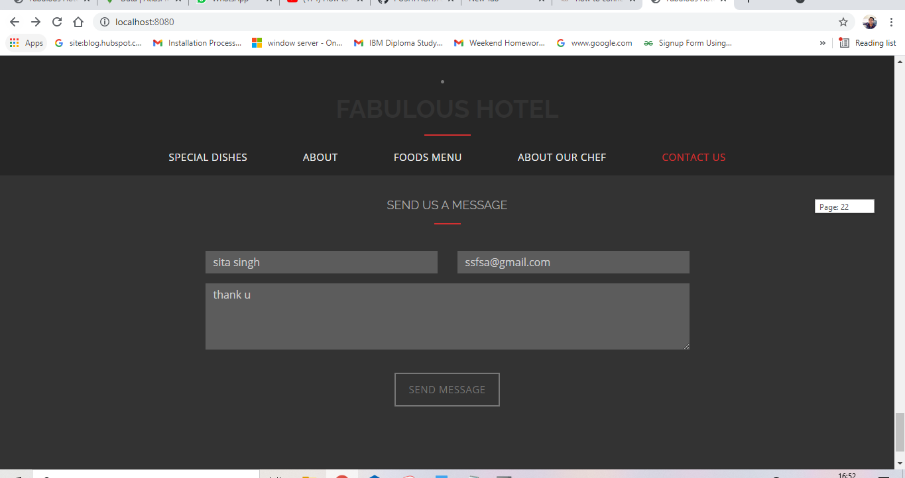

**Open thank u page**

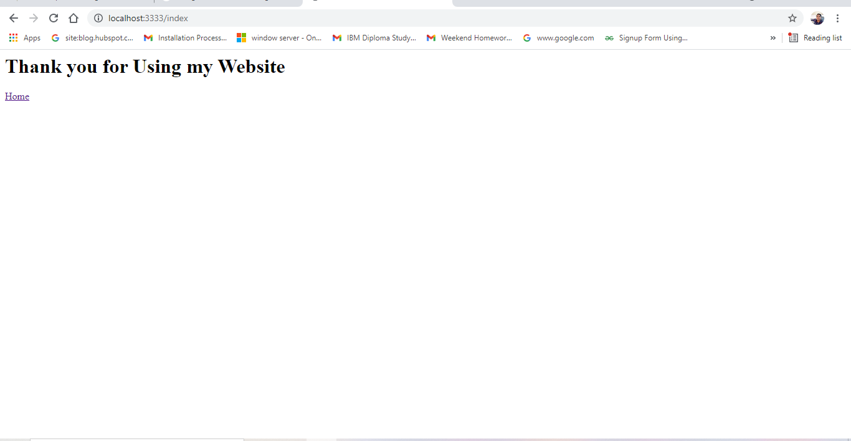

**See where store your data in atlas**

**Click on collections**

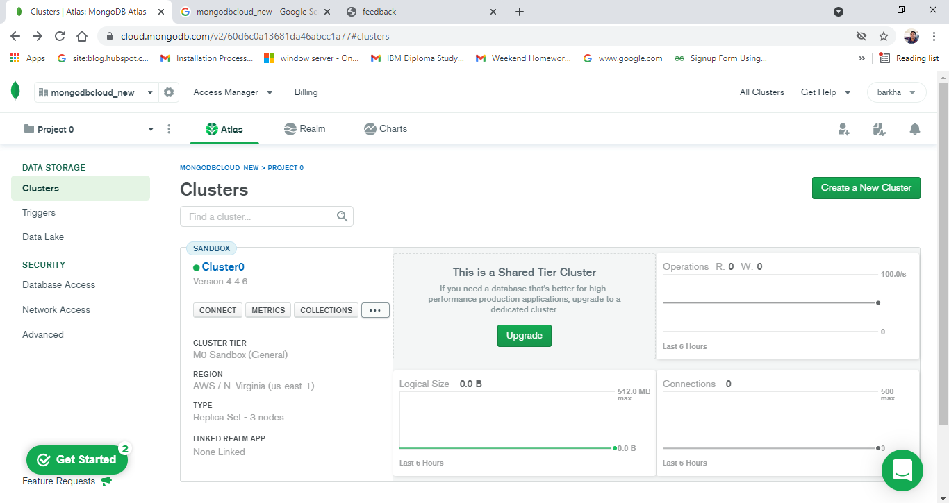

**You can see by default creating a database myFirstDatabase and collection details**

**Store user data in details**

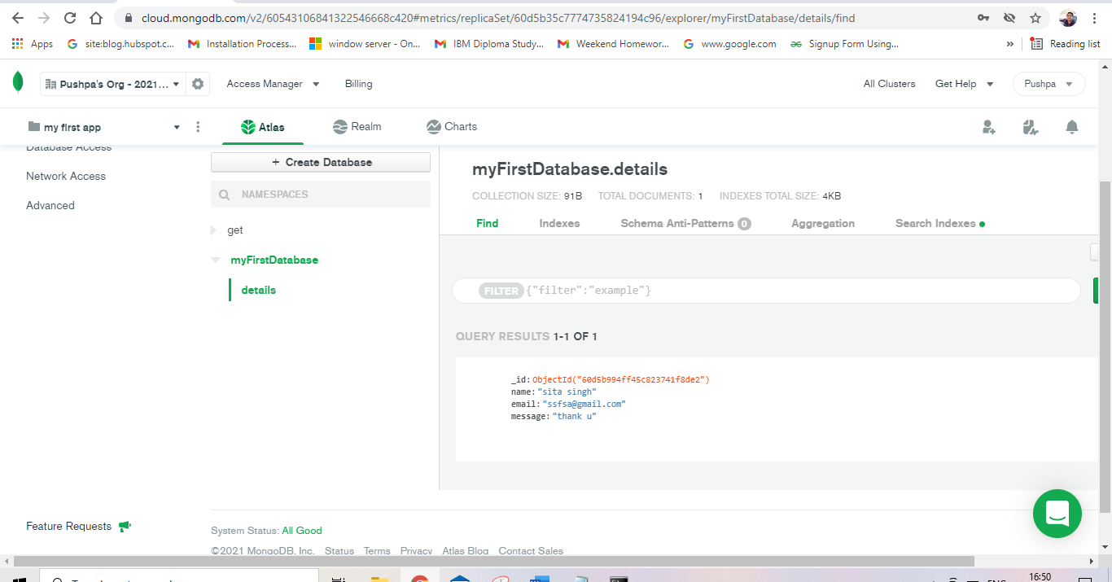

**Source code**

**Index.html**

<!DOCTYPE html>

<html lang="en">

<head>

<meta charset="utf-8">

<meta name="viewport" content="width=device-width, initial-scale=1">

<title>Fabulous Hotel</title>

<link rel="shortcut icon" href="img/favicon.ico" type="image/x-icon">

<link rel="apple-touch-icon" href="img/apple-touch-icon.png">

<link rel="apple-touch-icon" sizes="72x72" href="img/apple-touch-icon-72x72.png">

<link rel="apple-touch-icon" sizes="114x114" href="img/apple-touch-icon-114x114.png">

<!-- Bootstrap -->

<link rel="stylesheet" type="text/css" href="css/bootstrap.css">

<link rel="stylesheet" type="text/css" href="fonts/font-awesome/css/font-awesome.css">

<!-- Stylesheet

================================================== -->

<link rel="stylesheet" type="text/css" href="css/style.css">

<link href="https://fonts.googleapis.com/css?family=Raleway:300,400,500,600,700" rel="stylesheet">

<link href="https://fonts.googleapis.com/css?family=Open+Sans:300,400,600,700" rel="stylesheet">

<link href="https://fonts.googleapis.com/css?family=Rochester" rel="stylesheet">

<script src="https://oss.maxcdn.com/html5shiv/3.7.2/html5shiv.min.js"></script>

<script src="https://oss.maxcdn.com/respond/1.4.2/respond.min.js"></script>

</head>

<body id="page-top" data-spy="scroll" data-target=".navbar-fixed-top">

<nav id="menu" class="navbar navbar-default navbar-fixed-top">

<div class="container">

<!-- Brand and toggle get grouped for better mobile display -->

<div class="navbar-header">

<button type="button" class="navbar-toggle collapsed" data-toggle="collapse" data-target="#bs-example-navbar-collapse-1"> <span class="sr-only">Toggle navigation</span> <span class="icon-bar"></span> <span class="icon-bar"></span> <span class="icon-bar"></span> </button>

</div>

<!-- Collect the nav links, forms, and other content for toggling -->

<div class="collapse navbar-collapse" id="bs-example-navbar-collapse-1">

<ul class="nav navbar-nav"></ul>

<li><h2><b>fabulous hotel</b></h2> </li>

<ul class="nav navbar-nav">

<li><a href="#features" class="page-scroll">Special dishes</a></li>

<li><a href="#about" class="page-scroll">About</a></li>

<li><a href="#restaurant-menu" class="page-scroll"> foods Menu </a></li>

<li><a href="#team" class="page-scroll">about our Chef</a></li>

<li><a href="#contact" class="page-scroll">Contact us</a></li>

</ul>

</div>

<!-- /.navbar-collapse -->

</div>

</nav>

<!-- Header -->

<header id="header">

<div class="intro">

<div class="overlay">

<div class="container">

<div class="row">

<div class="intro-text">

<h1>Fabulous Hotel</h1>

<p>welcome to Fabulous hotel</p>

</div>

</div>

</div>

</div>

</div>

</header>

<!-- Features Section -->

<div id="features" class="text-center">

<div class="container">

<div class="section-title">

<h2>Our Specials dishes</h2>

</div>

<div class="row">

<div class="col-xs-12 col-sm-4">

<div class="features-item">

<h3>famous dish of patna</h3>

<img src="img/specials/1.jpg" class="img-responsive" alt="">

<p>Dishes for which Bihar is famous include Bihari kebabs, litti chokha, Bihari boti, Bihari chicken masala, sattu paratha (parathas stuffed with roasted gram flour), chokha (spicy mashed eggplant and potatoes), fish curry and posta-dana ka halwa.

</p>

</div>

</div>

<div class="col-xs-12 col-sm-4">

<div class="features-item">

<h3>Dahi btata puri</h3>

<img src="img/specials/2.jpg" class="img-responsive" alt="">

<p>Dahipuri, or dahi puri, is a snack, originating from India, The dish is a form of chaat and originates from the city of Mumbai. It is served with mini-puri shells, which are more popularly recognized from the dish pani puri</p>

</div>

</div>

<div class="col-xs-12 col-sm-4">

<div class="features-item">

<h3>baingan ka bharta</h3>

<img src="img/specials/3.jpg" class="img-responsive" alt="">

<p>Baingan bharta is a spiced and mashed aubergine or eggplant dish popular in the Indian cuisine</p>

</div>

</div>

</div>

</div>

</div>

<!-- About Section -->

<div id="about">

<div class="container-fluid">

<div class="row">

<div class="col-xs-12 col-md-6 about-img"> </div>

<div class="col-xs-12 col-md-3 col-md-offset-1">

<div class="about-text">

<div class="section-title">

<h2>About Our hotel</h2>

</div>

<p>Fabulous one of the fine dining restaurants . It’s the place to go for North Indian food, as well as anything with a touch of North West Frontier Province flavors.</p>

<p> The ambiance is somewhat classical with solid furniture and exposed red brick walls. Specialities include meat heavy Mughali, Afghan, and tandoori dishes.</p>

</div>

</div>

</div>

</div>

</div>

<!-- Restaurant Menu Section -->

<div id="restaurant-menu">

<div class="container">

<div class="section-title text-center">

<h2>Food Menu</h2>

</div>

<div class="row">

<div class="col-xs-12 col-sm-6">

<div class="menu-section">

<h2 class="menu-section-title">Breakfast & Starters</h2>

<div class="menu-item">

<h2 class="menu-item">For vegetarian</h2>

<div class="menu-item-name">Multigrain Roti</div>

<div class="menu-item-price"> 90Rs. </div>

<div class="menu-item-name">Oats Upma</div>

<div class="menu-item-price"> 70Rs. </div>

<div class="menu-item-name">Ven Pongal</div>

<div class="menu-item-price"> 80Rs. </div>

<div class="menu-item-name">Methi Thalipeeth</div>

<div class="menu-item-price"> 110Rs. </div>

<div class="menu-item-name">Green Tea</div>

<div class="menu-item-price"> 70Rs. </div>

<div class="menu-item-name">Coffee</div>

<div class="menu-item-price"> 60Rs. </div>

<h2 class="menu-item">For Non-vegetarian</h2>

<div class="menu-item-name">Grilled Chicken Escalope with Fresh Salsa</div>

<div class="menu-item-price">290Rs. </div>

<div class="menu-item-name">Mutton Korma.</div>

<div class="menu-item-price"> 170Rs. </div>

<div class="menu-item-name">Pina Colada Pork Ribs</div>

<div class="menu-item-price"> 280Rs. </div>

<div class="menu-item-name">Tandoori Lamb Chops</div>

<div class="menu-item-price"> 110Rs. </div>

<div class="menu-item-name">Eggs</div>

<div class="menu-item-price"> 40Rs. </div>

<div class="menu-item-name">Malabar Fish Biryani</div>

<div class="menu-item-price"> 170Rs. </div>

<div class="menu-item-description"> Kerala style Fish Biryani is prepared using Khaima/ Jeerakasala rice. Seer Fish/ Neymmeen or any other fleshy fish can be used for making this </div>

</div>

<div class="menu-item">

<div class="menu-item-name">Fried Ravioli</div>

<div class="menu-item-price"> 700RS. </div>

<div class="menu-item-description">Dredge ravioli in the bread crumbs. Place the ravioli on a baking sheet, and continue with the remaining ravioli. When the oil is hot, fry the ravioli in batches, turning occasionally, until golden brown, about 3 minutes. Using a slotted spoon, transfer the fried ravioli to paper towels to drain.

</div>

</div>

<div class="menu-item">

<div class="menu-item-name">Wild Mushroom Arancini</div>

<div class="menu-item-price"> 290Rs. </div>

<div class="menu-item-description"> Ingredients. 2 cups wild mushroom risotto, cooled. 2 large eggs, beaten to blend. Directions. In a large, heavy saucepan, add about 2″ of oil. Heat the oil over medium heat until it's bout 350F. Notes. Feel free to use whatever leftover risotto you may have on hand for this – or your favorite risotto recipe! </div>

</div>

</div>

</div>

<div class="col-xs-12 col-sm-6">

<div class="menu-section">

<h2 class="menu-section-title">Main Dishes</h2>

<div class="menu-item">

<div class="menu-item-name">Litti chokha</div>

<div class="menu-item-price"> 180Rs.</div>

<div class="menu-item-description">Litti, along with chokha, is a complete meal originated from the Indian state of Bihar. It is also popular in Jharkhand and parts of Eastern Uttar Pradesh. </div>

</div>

<div class="menu-item">

<div class="menu-item-name">Chicken & Mushroom Pasta</div>

<div class="menu-item-price"> 420Rs. </div>

<div class="menu-item-description">How to make Chicken Mushroom Pasta (quick summary) Melt butter in pan. Add mushrooms. Fry until golden. Add wine, reduce down, then pour in chicken stock. Pour in cream and simmer to thicken. Add parmesan, parsley and seasoning. Stir in pasta. Add chicken strips</div>

</div>

<div class="menu-item">

<div class="menu-item-name">Biryani</div>

<div class="menu-item-price"> 190Rs. </div>

<div class="menu-item-description"> How to make Chicken Mushroom Pasta (quick summary) Melt butter in pan. Add mushrooms. Fry until golden. Add wine, reduce down, then pour in chicken stock. Pour in cream and simmer to thicken. Add parmesan, parsley and seasoning. Stir in pasta. Add chicken strips </div>

</div>

<div class="menu-item">

<div class="menu-item-name">Papri chat</div>

<div class="menu-item-price"> 190Rs. </div>

<div class="menu-item-description">Papri chat or papri chaat is a popular traditional fast food and street food from the Indian subcontinent, probably in North India, Bangladesh and Pakistan.</div>

</div>

</div>

</div>

</div>

<div class="row">

<div class="col-xs-12 col-sm-6">

<div class="menu-section">

<h2 class="menu-section-title">Dinner</h2>

<div class="menu-item">

<div class="menu-item-name">Caprese Pasta Salad.</div>

<div class="menu-item-price"> 250Rs. </div>

<div class="menu-item-description">cups cherry tomatoes, halved. 8 oz bocconcini fresh mozzarella balls (or fresh mozzarella cut into 1/2" cubes) 12 oz dried orecchiette pasta </div>

</div>

<div class="menu-item">

<div class="menu-item-name">Malai Kofta </div>

<div class="menu-item-price"> 170Rs. </div>

<div class="menu-item-description">Malai Kofta is a very popular Indian vegetarian dish where balls (kofta) made of potato and paneer are deep fried and served with a creamy and spiced tomato based curry. The literal translation of this dish is malai=creamy/buttery and kofta=spiced balls (in this case made of potatoes and paneer).</div>

</div>

<div class="menu-item">

<div class="menu-item-name">Mushroom Kofta in Tomato Gravy. .</div>

<div class="menu-item-price"> 280Rs. </div>

<div class="menu-item-description"> How to Make Mushroom Kofta in Tomato Gravy. Wash and chop spinach leaves. Remove and add paneer, corn flour, wheat flour and salt. For the Filling: Take oil in a pan, add ginger paste, green chillies, finely chopped white button mushrooms and salt. Add lemon juice and honey and mix well. </div>

</div>

<div class="menu-item">

<div class="menu-item-name">Spicy Coconut Salmon</div>

<div class="menu-item-price"> 420Rs. </div>

<div class="menu-item-description"> In a saucepan over medium heat, warm 1 teaspoon olive oil and cook garlic, onions, ginger, and red pepper flakes until softened, 3 minutes. Meanwhile, preheat a large cast-iron skillet over medium-high heat. Serve salmon with warm spicy coconut milk sauce and top with red pepper flakes and cilantro.

25 mins</div>

</div>

</div>

</div>

<div class="col-xs-12 col-sm-6">

<div class="menu-section">

<h2 class="menu-section-title">Desserts</h2>

<div class="menu-item">

<div class="menu-item-name">Chocolate Mud Cake</div>

<div class="menu-item-price"> 410Rs. </div>

<div class="menu-item-description">Deliciously moist and rich, this is definitely THE best ever cake for chocolate lovers. One piece is never enough! </div>

</div>

<div class="menu-item">

<div class="menu-item-name">Bourbon-Pecan Tart</div>

<div class="menu-item-price"> 240Rs. </div>

<div class="menu-item-description">Bourbon Pecan Tart ... Gooey and sticky sweet, pecan pie is the quintessential Southern dessert. Here it is transformed into a buttery tart that requires less sugar</div>

</div>

<div class="menu-item">

<div class="menu-item-name">Texas Sheet Cake</div>

<div class="menu-item-price"> 500Rs. </div>

<div class="menu-item-description">A moist and delicious chocolate cake made in a jellyroll pan, covered with chocolate frosting and walnuts.</div>

</div>

<div class="menu-item">

<div class="menu-item-name">Vanilla Cheesecake</div>

<div class="menu-item-price">280Rs. </div>

<div class="menu-item-description"> A cheesecake can be savory (and served with crackers as an appetizer), however, most of us think of the term as describing a luscious, rich and sweet dessert. The texture can vary greatly-from light and airy to dense and rich to smooth and creamy depending on the ingredients and mixing methods used.</div>

</div>

</div>

</div>

</div>

</div>

</div>

<!-- Gallery Section -->

<div id="gallery">

<div class="container-fluid">

<div class="row">

<div class="col-xs-6 col-md-3">

<div class="gallery-item"> <img src="img/gallery/01.jpg" class="img-responsive" alt=""></div>

</div>

<div class="col-xs-6 col-md-3">

<div class="gallery-item"> <img src="img/gallery/02.jpg" class="img-responsive" alt=""></div>

</div>

<div class="col-xs-6 col-md-3">

<div class="gallery-item"> <img src="img/gallery/03.jpg" class="img-responsive" alt=""></div>

</div>

<div class="col-xs-6 col-md-3">

<div class="gallery-item"> <img src="img/gallery/04.jpg" class="img-responsive" alt=""></div>

</div>

</div>

</div>

</div>

<!-- Team Section -->

<div id="team">

<div class="container">

<div id="row">

<div class="col-md-6">

<div class="col-md-10 col-md-offset-1">

<div class="section-title">

<h2>Meet Our Chef</h2>

</div>

<p>Our passionate culinary team is made up of innovative and experienced professionals with years of experience in foodservice. Their work combines food science, technology and the culinary arts to imagine the future of food.</p>

<p> They draw on current trends and culinary insights from across our global network to create customized solutions for all of our clients. Using proprietary flavor research, our team of forward-thinking chefs aims to guide the next phase of foodservice. Individually, they've earned accolades across the industry, but together they're crafting the future of flavor!

</p>

</div>

</div>

<div class="col-md-6">

<div class="team-img"><img src="img/chef.jpg" alt="..."></div>

</div>

</div>

</div>

</div>

<!-- Contact Section -->

<div id="contact" class="text-center">

<div class="container text-center">

<div class="col-md-4">

<h3>Reservations</h3>

<div class="contact-item">

<p>Please call</p>

<p>+918998763320</p>

</div>

</div>

<div class="col-md-4">

<h3>Address</h3>

<div class="contact-item">

<p>Patna(Bihar)india</p>

<p> boring road 80001</p>

</div>

</div>

<div class="col-md-4">

<h3>Opening Hours</h3>

<div class="contact-item">

<p>Mon-Thus: 10:00 AM - 11:00 PM</p>

<p>Fri-Sun: 11:00 AM - 02:00 AM</p>

</div>

</div>

</div>

<div class="container">

<div class="section-title text-center">

<h3>Send us a message</h3>

</div>

<div class="col-md-8 col-md-offset-2">

<form action="/index" method="POST"name="sentMessage" id="contactForm" novalidate>

<div class="row">

<div class="col-md-6">

<div class="form-group">

<input type="text" id="name" name="name" class="form-control" placeholder="Type your Name" required="required">

<p class="help-block text-danger"></p>

</div>

</div>

<div class="col-md-6">

<div class="form-group">

<input type="email" id="email" name="email" class="form-control" placeholder="Type your Email" required="required">

<p class="help-block text-danger"></p>

</div>

</div>

</div>

<div class="form-group">

<textarea name="message" id="message" class="form-control" name="message" rows="4" placeholder=" Type your Message" required></textarea>

<p class="help-block text-danger"></p>

</div>

<div id="success"></div>

<button type="submit" class="btn btn-custom btn-lg">Send Message</button>

</form>

</div>

</div>

</div>

<div id="footer">

<div class="container text-center">

<div class="col-md-6">

</div>

<div class="col-md-6">

<div class="social">

<ul>

<li><a href="#"><i class="fa fa-facebook"></i></a></li>

<li><a href="#"><i class="fa fa-twitter"></i></a></li>

<li><a href="#"><i class="fa fa-youtube"></i></a></li>

</ul>

</div>

</div>

</div>

</div>

<!---waston assistant -->

<script>

window.watsonAssistantChatOptions = {

integrationID: "5103c32c-f97b-475c-a8a8-01e5c1dc3fed", // The ID of this integration.

region: "eu-gb", // The region your integration is hosted in.

serviceInstanceID: "5ce2bc46-b04c-4517-8eb0-fcef75251731", // The ID of your service instance.

onLoad: function(instance) { instance.render(); }

};

setTimeout(function(){

const t=document.createElement('script');

t.src="https://web-chat.global.assistant.watson.appdomain.cloud/loadWatsonAssistantChat.js";

document.head.appendChild(t);

});

</script>

<script type="text/javascript" src="js/jquery.1.11.1.js"></script>

<script type="text/javascript" src="js/bootstrap.js"></script>

<script type="text/javascript" src="js/SmoothScroll.js"></script>

<script type="text/javascript" src="js/jqBootstrapValidation.js"></script>

<script type="text/javascript" src="js/main.js"></script>

</body>

</html>

Style.css

body, html {

font-family: 'Open Sans', serif;

text-rendering: optimizeLegibility !important;

-webkit-font-smoothing: antialiased !important;

color: #777;

font-weight: 400;

width: 100% !important;

height: 100% !important;

}

h1, h2, h3, h4 {

font-family: 'Raleway', sans-serif;

}

h2 {

font-weight: 400;

font-size: 38px;

color: #333;

text-transform: uppercase;

position: relative;

margin-top: 10px;

margin-bottom: 15px;

padding-bottom: 20px;

}

h2::after {

position: absolute;

content: "";

background: #d43031;

height: 2px;

width: 70px;

bottom: 0;

margin-left: -35px;

left: 50%;

}

h3 {

font-size: 24px;

font-weight: 400;

color: #333;

}

h4 {

font-size: 24px;

text-transform: uppercase;

font-weight: 400;

color: #333;

}

h5 {

text-transform: uppercase;

font-weight: 700;

line-height: 20px;

}

p {

font-size: 15px;

}

p.intro {

margin: 12px 0 0;

line-height: 24px;

}

a {

color: #8eb640;

}

a:hover, a:focus {

text-decoration: none;

color: #222;

}

ul, ol {

list-style: none;

}

ul, ol {

padding: 0;

webkit-padding: 0;

moz-padding: 0;

}

.btn:active, .btn.active {

background-image: none;

outline: 0;

-webkit-box-shadow: none;

box-shadow: none;

}

a:focus, .btn:focus, .btn:active:focus, .btn.active:focus, .btn.focus, .btn:active.focus, .btn.active.focus {

outline: none;

outline-offset: none;

}

/* Navigation */

.navbar .navbar-nav {

display: inline-block;

float: none;

vertical-align: top;

}

.navbar .navbar-collapse {

text-align: center;

}

#menu {

padding: 20px;

transition: all 0.8s;

}

#menu.navbar-default {

background-color: rgba(248, 248, 248, 0);

border-color: rgba(231, 231, 231, 0);

}

#menu.navbar-default .navbar-nav > li > a {

text-transform: uppercase;

color: #eee;

font-weight: 400;

font-size: 15px;

padding: 5px 0;

border: 2px solid transparent;

letter-spacing: 0.5px;

margin: 0 40px 0 40px;

}

#menu.navbar-default .navbar-nav > li > a:hover {

color: #d43031;

}

.on {

background-color: #262626 !important;

padding: 0 !important;

padding: 10px 0 !important;

}

.navbar-default .navbar-nav > .active > a, .navbar-default .navbar-nav > .active > a:hover, .navbar-default .navbar-nav > .active > a:focus {

color: #d43031 !important;

background-color: transparent;

}

.navbar-toggle {

border-radius: 0;

}

.navbar-default .navbar-toggle:hover, .navbar-default .navbar-toggle:focus {

background-color: #d43031;

border-color: #d43031;

}

.navbar-default .navbar-toggle .icon-bar {

background-color: #FFF;

}

.navbar-default .navbar-toggle:hover>.icon-bar {

background-color: #FFF;

}

.section-title {

margin-bottom: 70px;

}

.section-title .overlay {

padding: 80px 0;

background: rgba(0, 0, 0, 0.7);

}

.section-title p {

font-size: 22px;

}

.section-title hr {

margin: 0 auto;

margin-bottom: 40px;

}

.btn-custom {

text-transform: uppercase;

color: #777;

background-color: transparent;

border: 2px solid #777;

padding: 14px 20px;

margin: 0;

font-size: 15px;

font-weight: 500;

letter-spacing: 0.5px;

border-radius: 0;

margin-top: 20px;

transition: all 0.3s;

}

.btn-custom:hover, .btn-custom:focus, .btn-custom.focus, .btn-custom:active, .btn-custom.active {

color: #ddd;

border: 2px solid #d43031;

background-color: #d43031;

}

/* Header Section */

.intro {

display: table;

width: 100%;

padding: 0;

background: url(../img/intro-bg.jpg) center center no-repeat;

background-color: #e5e5e5;

-webkit-background-size: cover;

-moz-background-size: cover;

background-size: cover;

-o-background-size: cover;

}

.intro .overlay {

background: rgba(0,0,0,0.4);

}

.intro h1 {

font-family: 'Rochester', cursive;

color: #fff;

font-size: 10em;

font-weight: 400;

margin-top: 0;

}

.intro span {

color: #a7c44c;

font-weight: 600;

}

.intro p {

color: #fff;

font-size: 24px;

font-weight: 400;

margin-top: 150px;

}

header .intro-text {

padding-top: 200px;

padding-bottom: 50px;

text-align: center;

}

/* Features Section */

#features {

padding: 120px 0;

}

#features .features-item {

margin: 0 20px;

}

#features img {

margin: 30px auto 20px;

}

#features .about-img:before {

display: block;

content: '';

position: absolute;

top: 8px;

right: 8px;

bottom: 8px;

left: 8px;

border: 1px solid rgba(255, 255, 255, 0.5);

}

#features p {

line-height: 24px;

margin: 15px 0 30px;

}

/* About Section */

#about {

padding: 0;

background: #f6f6f6;

}

#about h2::after {

bottom: 0;

margin-left: 0;

left: 0;

}

#about .about-text {

padding: 80px 0;

}

#about .about-img {

background: #444 url(../img/gallery-bg.jpg) center center no-repeat;

background-size: cover;

height: 570px;

}

#about p {

line-height: 24px;

margin: 15px 0 30px;

}

/* Menu Section */

#restaurant-menu {

padding: 100px 0 60px 0;

}

#restaurant-menu img {

width: 300px;

box-shadow: 15px 0 #a7c44c;

}

#restaurant-menu h3 {

padding: 10px 0;

text-transform: uppercase;

}

#restaurant-menu .menu-section hr {

margin: 0 auto;

}

#restaurant-menu .menu-section {

margin: 0 20px 80px;

}

#restaurant-menu .menu-section-title {

font-size: 32px;

display: block;

font-weight: 400;

color: #444;

margin: 20px 0;

text-align: center;

}

#restaurant-menu .menu-item {

margin: 45px 0;

font-size: 18px;

}

#restaurant-menu .menu-item-name {

font-weight: 400;

font-size: 20px;

color: #444;

margin-bottom: 10px;

}

#restaurant-menu .menu-item-description {

font-size: 15px;

width: 85%;

}

#restaurant-menu .menu-item-price {

float: right;

font-weight: 400;

color: #555;

margin-top: -36px;

}

/* Gallery Section */

#gallery {

padding: 0;

}

#gallery .gallery-item {

margin: 0 -15px;

}

/* Team Section */

#team {

padding: 120px 0;

}

#team h2::after {

bottom: 0;

margin-left: 0;

left: 0;

}

#team img {

max-width: 550px;

}

#team .team-img {

display: inline-block;

position: relative;

}

/* Contact Section */

#contact {

padding: 100px 0;

background: #333;

}

#contact .contact-item p {

font-size: 15px;

color: #777;

}

#contact .section-title {

margin-top: 60px;

margin-bottom: 40px;

}

#contact form {

padding: 0;

}

#contact h3 {

position: relative;

text-transform: uppercase;

font-size: 18px;

font-weight: 400;

color: #aaa;

padding: 20px 0;

}

#contact h3::after {

position: absolute;

content: "";

background: #d43031;

height: 2px;

width: 40px;

bottom: 0;

margin-left: -20px;

left: 50%;

}

#contact .text-danger {

color: #cc0033;

text-align: left;

}

label {

font-size: 12px;

font-weight: 400;

font-family: 'Open Sans', sans-serif;

float: left;

}

#contact .form-control {

display: block;

width: 100%;

padding: 6px 12px;

font-size: 16px;

line-height: 1.42857143;

color: #ccc;

background-color: rgba(255,255,255,.2);

background-image: none;

border: 0;

border-radius: 0;

-webkit-box-shadow: none;

box-shadow: none;

-webkit-transition: none;

-o-transition: none;

transition: none;

}

#contact .form-control:focus {

border-color: #999;

outline: 0;

-webkit-box-shadow: transparent;

box-shadow: transparent;

}

.form-control::-webkit-input-placeholder {

color: #999;

}

.form-control:-moz-placeholder {

color: #999;

}

.form-control::-moz-placeholder {

color: #999;

}

.form-control:-ms-input-placeholder {

color: #999;

}

#contact .contact-item {

margin: 20px 0 40px 0;

}

#contact .contact-item span {

font-weight: 400;

color: #aaa;

text-transform: uppercase;

margin-bottom: 6px;

display: inline-block;

}/* Footer Section*/

#footer {

background: #262626;

padding: 40px 0 20px 0;

}

#footer .social {

margin-top: -5px;

text-align: right;

}

#footer .social ul li {

display: inline-block;

margin: 0 15px;

}

#footer .social i.fa {

font-size: 24px;

padding: 4px;

color: #888;

transition: all 0.3s;

}

#footer .social i.fa:hover {

color: #eee;

}

#footer p {

font-size: 14px;

color: #666;

}

#footer a {

color: #999;

}

#footer a:hover {

color: #eee;

}

App.js

var express=require('express');

var bodyParser=require('body-parser');

const mongoose = require('mongoose');

mongoose.connect('mongodb://localhost:27017/fruits');

var db=mongoose.connection;

db.on('error', console.log.bind(console, 'connection error'));

db.once('open', function(callback){

console.log('connection succeeded');

})

var app=express()

var path=require('path');

app.use(bodyParser.json());

app.use(express.static('public'));

app.use('/images', express.static(__dirname + '/Images'));

app.use(bodyParser.urlencoded({

extended: false

}));

app.set('view engine','ejs');

app.post('/index', function(req,res){

var name = req.body.name;

var email =req.body.email;

var message =req.body.message;

var data = {"name":name,"email":email,"message":message}

db.collection('details').insertOne(data,function(err, collection){

if (err) throw err;

console.log("Record inserted Successfully");

});

return res.render('message');

})

app.get('/message',function(req,res){

res.sendFile( path.join(__dirname + '/index.html'));

})

app.get('/',function(req,res){

res.sendFile( path.join(__dirname + '/index.html'));

}).listen(8080)

Package.json

{

"name": "my-project",

"version": "1.0.0",

"main": "app.js",

"dependencies": {

"body-parser": "^1.19.0",

"ejs": "^3.1.6",

"express": "^4.17.1",

"mongodb": "^3.6.6",

"mongoose": "^5.12.14"

},

"devDependencies": {},

"scripts": {

"test": "echo \"Error: no test specified\" && exit 1"

},

"author": "",

"license": "ISC",

"description": ""

}

**Conclusion**

Hotel management system now-a-day have the advantage of modernization. Computer have done the work more easy. Computer is playing a important role in management. Reports are made on daily basis for every customer check in or check out which can easily be seen by the management.Hotel management system has also primary purpose is to provide facilities to customers. A software for computers makes the things many times easy, these are made as user friendly and to keep an check and balance in hotel management and accounts as well. So ,these things are important.

**References**

<https://www.mongodb.com/>

<https://cobusgreyling.medium.com/how-to-use-an-actions-skill-in-ibm-watson-assistant-4f05e6fd86b8>

<https://www.mongodb.com/blog/post/quick-start-nodejs-mongodb--how-to-get-connected-to-your-database>

**Screenshots**

**Home page**



**About page**

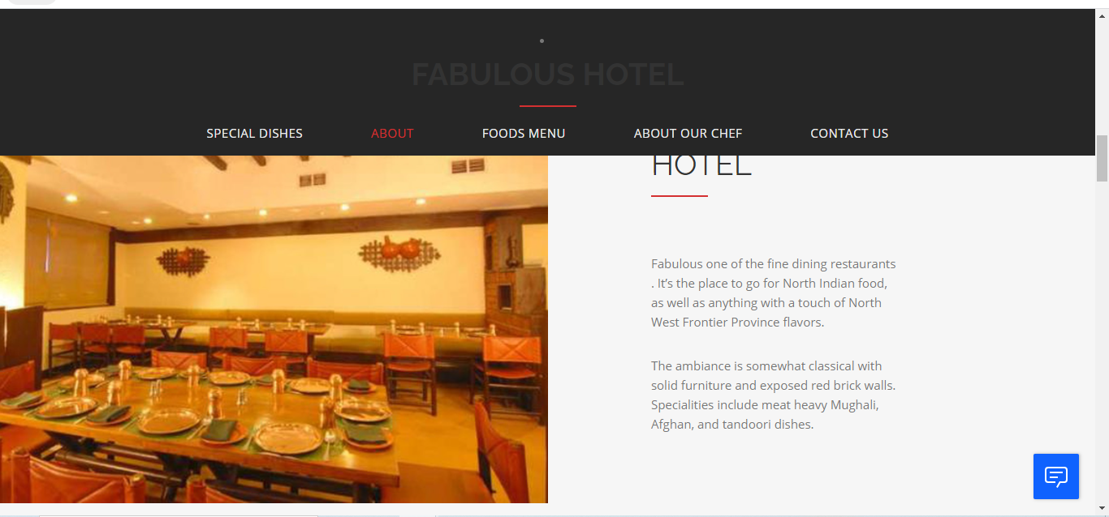

***food menu page***

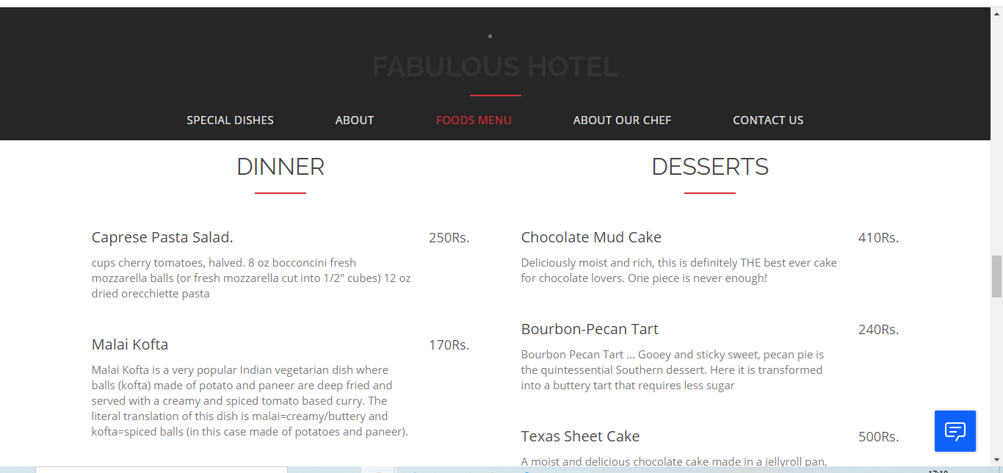

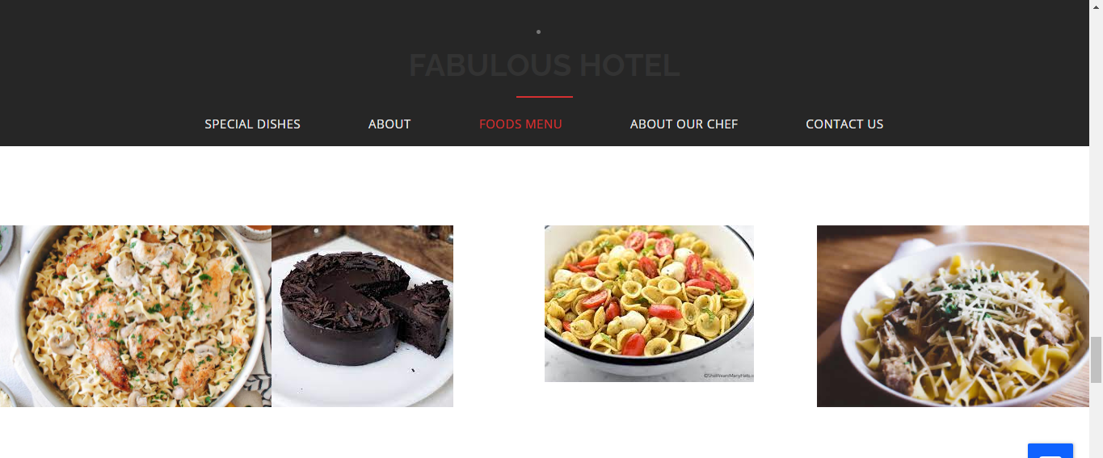

***our chef page page***

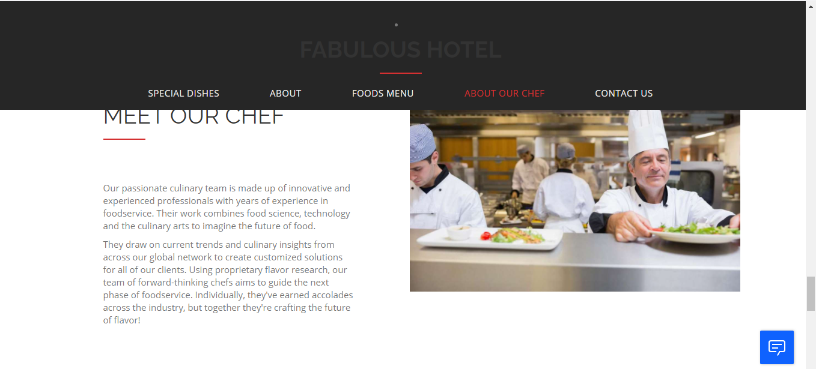

**contact us page**

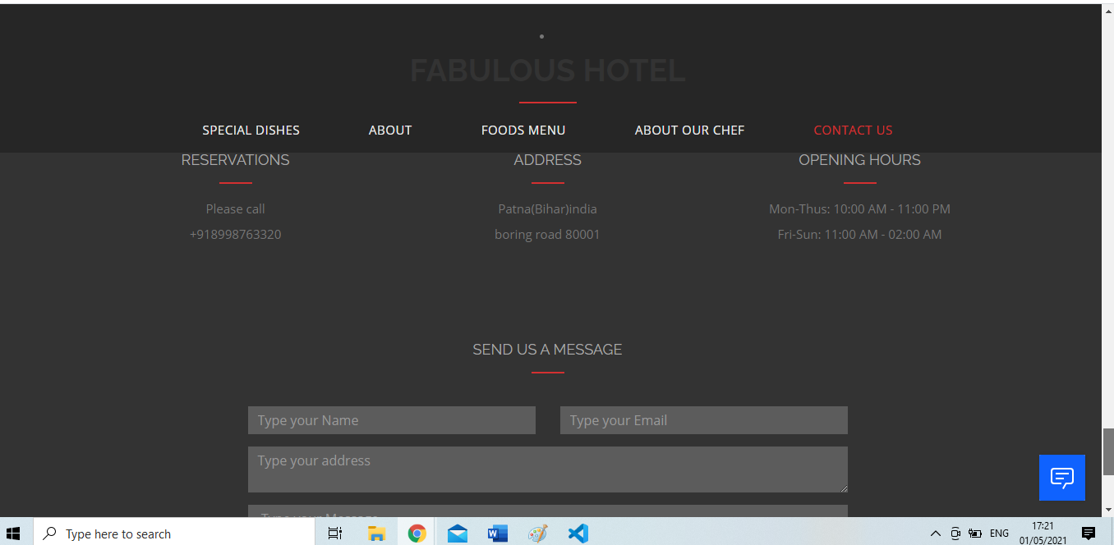

***In this field you can send your message***

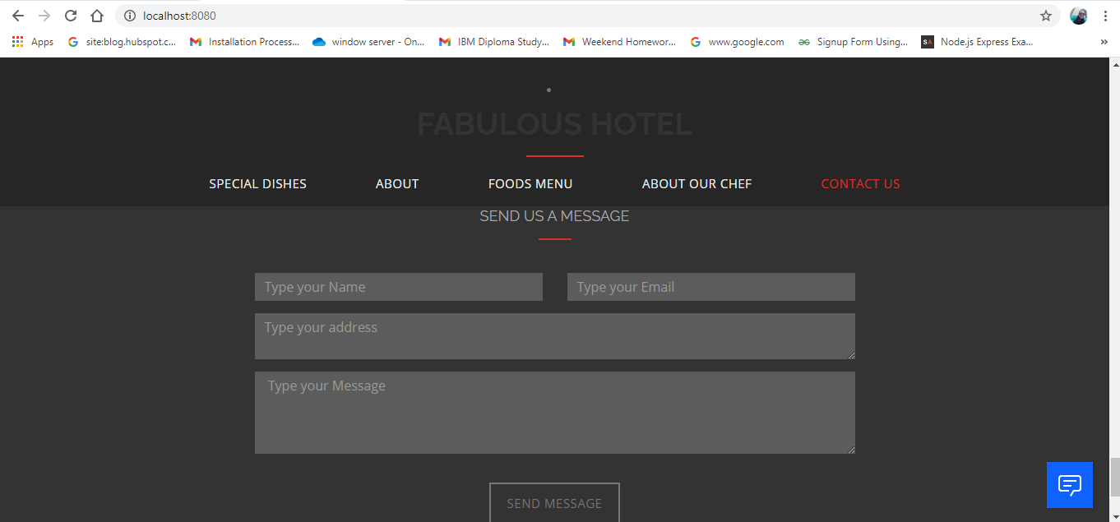

**Waston assistant**

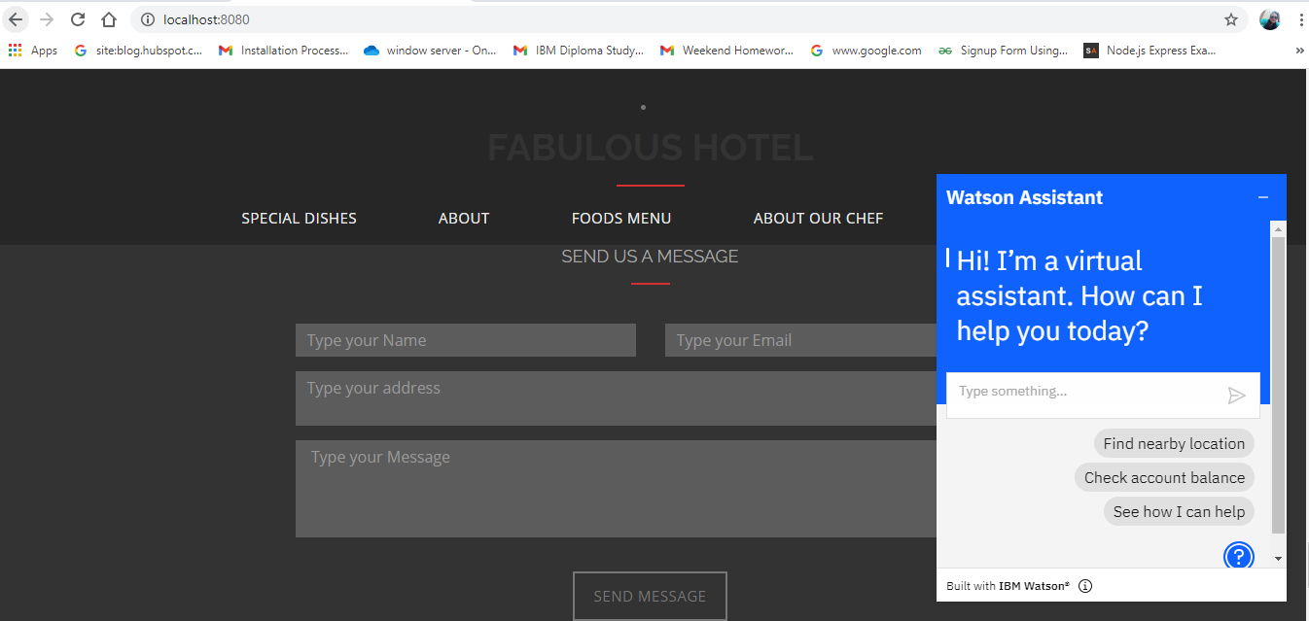

**THANK YOU….**